Name

Mathematics Extension 1 Year 11
Inverse Functions

Book 1 |  | Version: 261002  Feedback:  https://MrDingMaths.com
Contents
Syllabus Content 2
Learning Intention 3

Syllabus Content
ME1-11-01 solves problems involving inequalities, functions and their inverses, graphical relationships between functions, and parametric equations
Inverse functions
- Describe a function as one-to-one if every element in the range of the function corresponds to exactly one element of the domain
- Establish that the reflection of a point in the line $y=x$ reverses the coordinates of the point
- Define an inverse function $f^{-1}$ informally as a function that reverses or undoes the effect of the function $f$
- Recognise that inverse functions exist for one-to-one functions
- Determine the equation for the inverse function $f^{-1}(x)$ of a given one-to-one function $y=f(x)$ by interchanging the variables $x$ and $y$ in $y=f(x)$
- Compare the graphs of a function and its inverse function using graphing applications, and recognise that the two graphs are reflections of each other in the line $y=x$
- Establish that the domain of $f^{-1}\left(x\right)$ is the range of $f\left(x\right)$, and the range of $f^{-1}\left(x\right)$ is the domain of $f\left(x\right)$, and use this relationship to solve problems
- Graph the inverse function of a given one-to-one function
- Explain that the reflection in the line $y=x$ exchanges horizontal and vertical lines and recognise that the horizontal line test can therefore be applied to the graph of $y=f(x)$ to determine whether its reflection in the line $y=x$ is a function
- Apply restrictions to the domain of a function, if it is not one-to-one, to obtain an inverse function
- Define formally $f^{-1}(x)$ to be the inverse function of $f(x)$ if the relationships $f\left(f^{-1}\left(x\right)\right)=x$ and $f^{-1}\left(f\left(x\right)\right)=x$ hold, and use this definition to solve problems
- Solve problems based on the relationship between a function and its inverse function using algebraic and graphical techniques, including determining the points of intersection of a function and its inverse, where they exist

Reflection across $y=x$

- Reflection across $y=x$
Reflect the coordinates A, B, C across the line $y=x$.
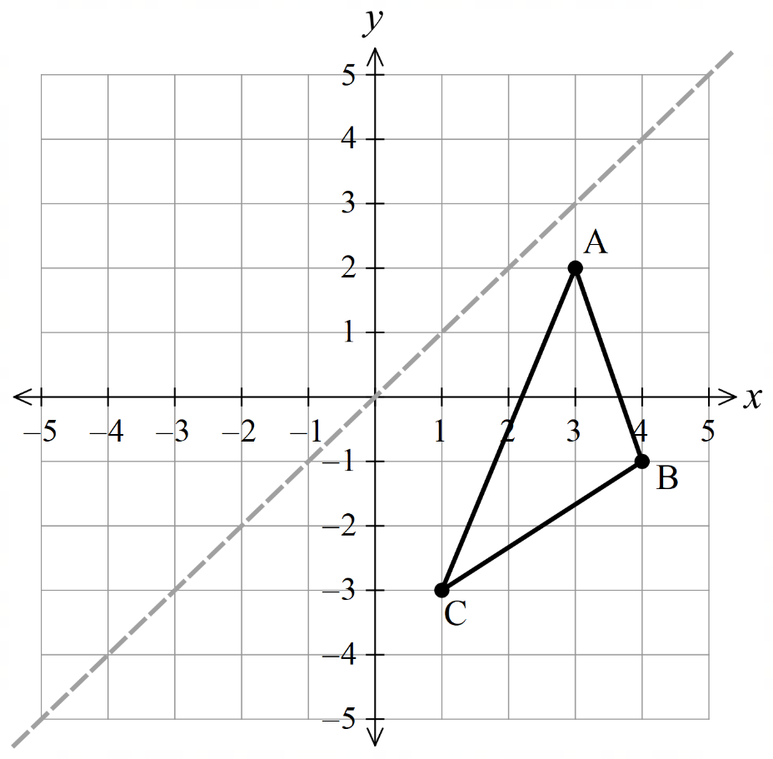

Original | A: | B: | C:
Reflection | A’: | B’: | C’:

What do you notice?

- Reflecting Across $y=x$
Exchange the $x$ and $y$-coordinates.
$$\left(x,y\right)$$
$$↓$$
$$\left(y,x\right)$$

- Guided Practice
Reflect these graphs across $y=x$.
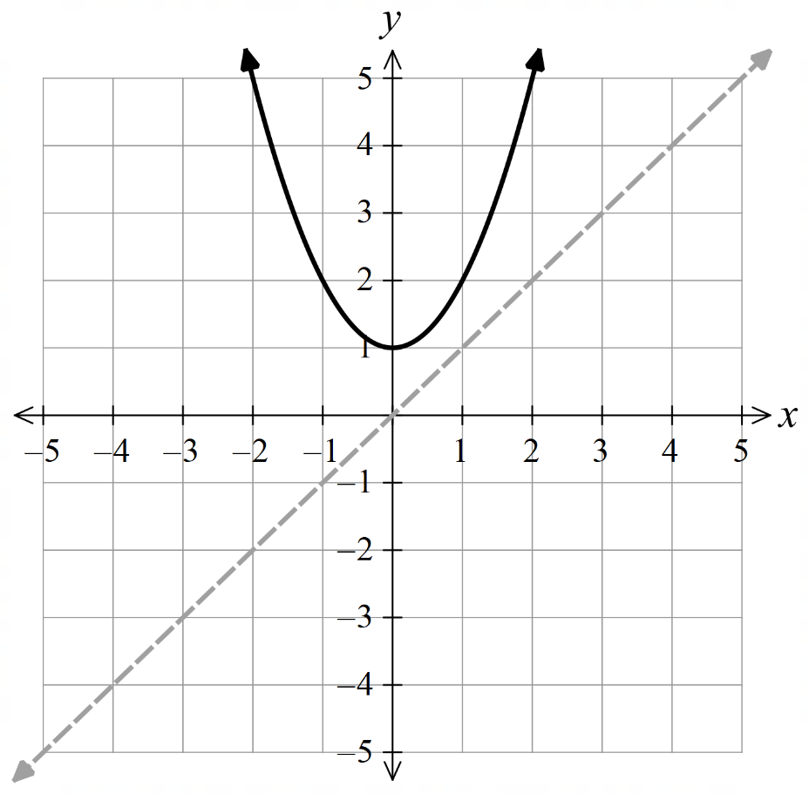
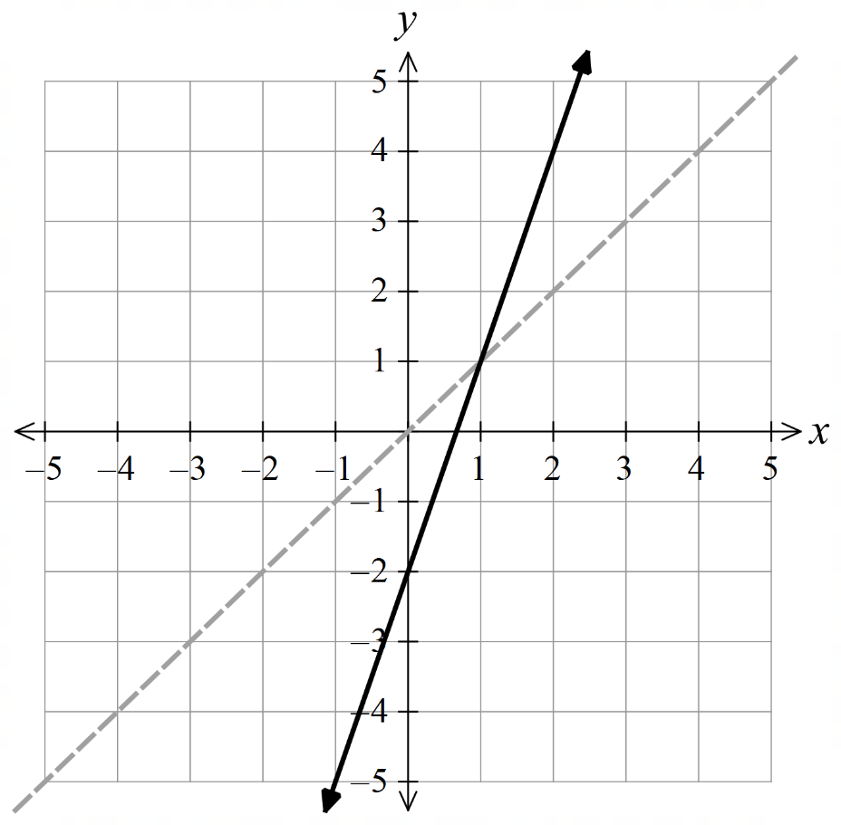

Foundation
- Sketch the reflection of these graphs across $y=x$.
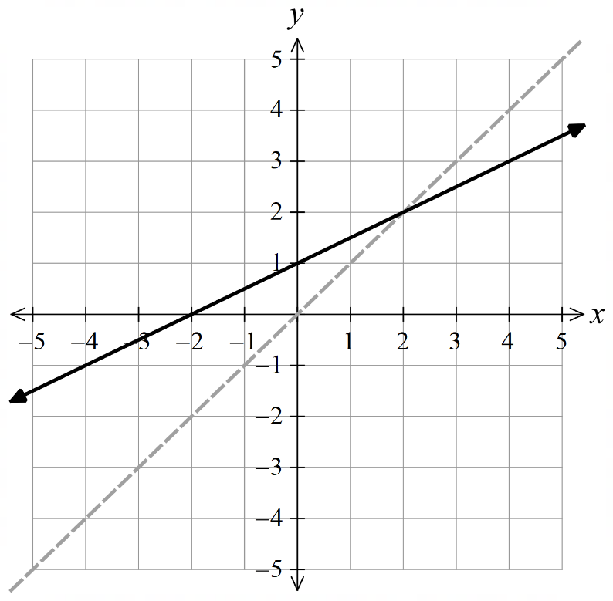  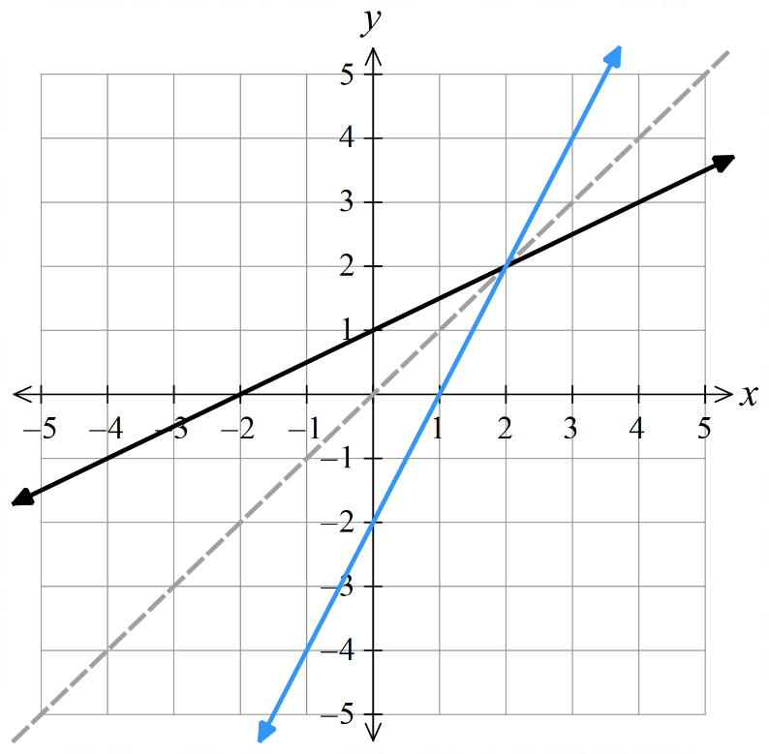 | 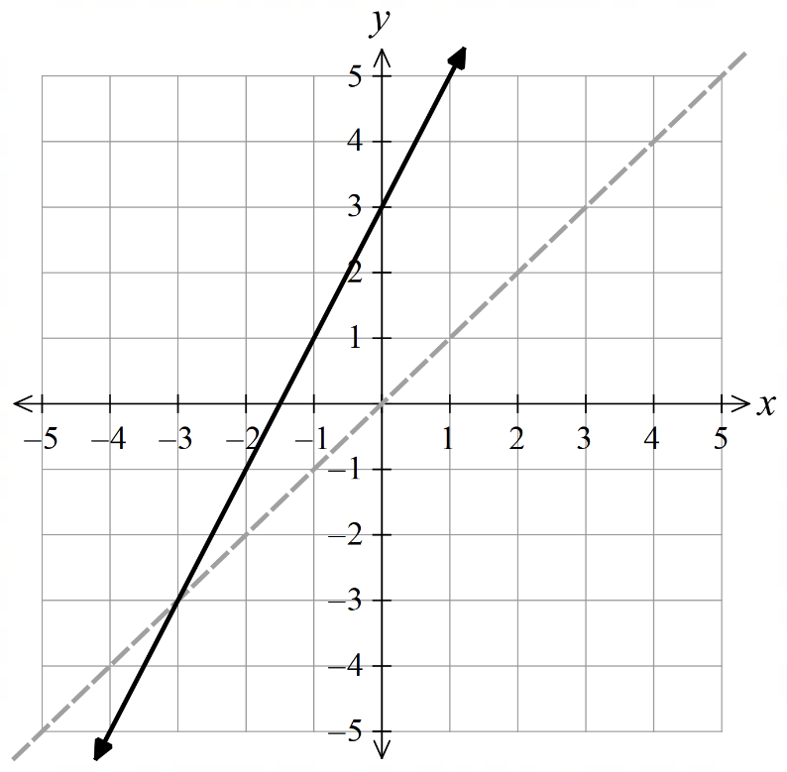  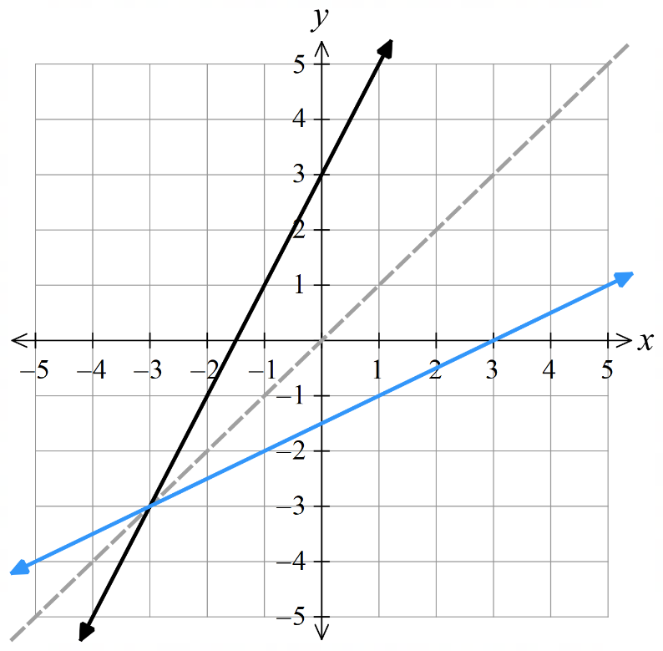
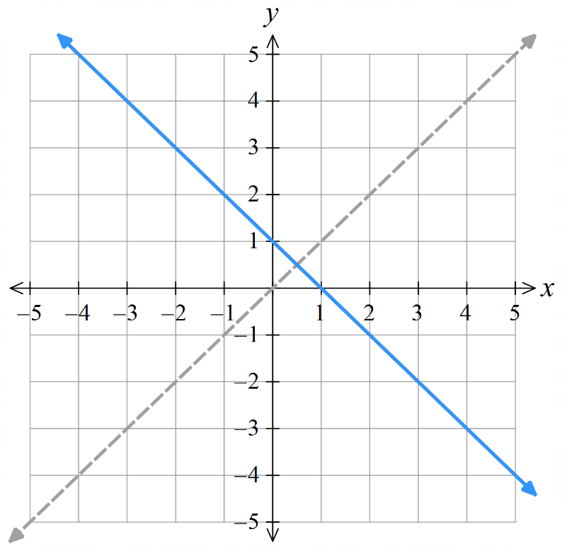  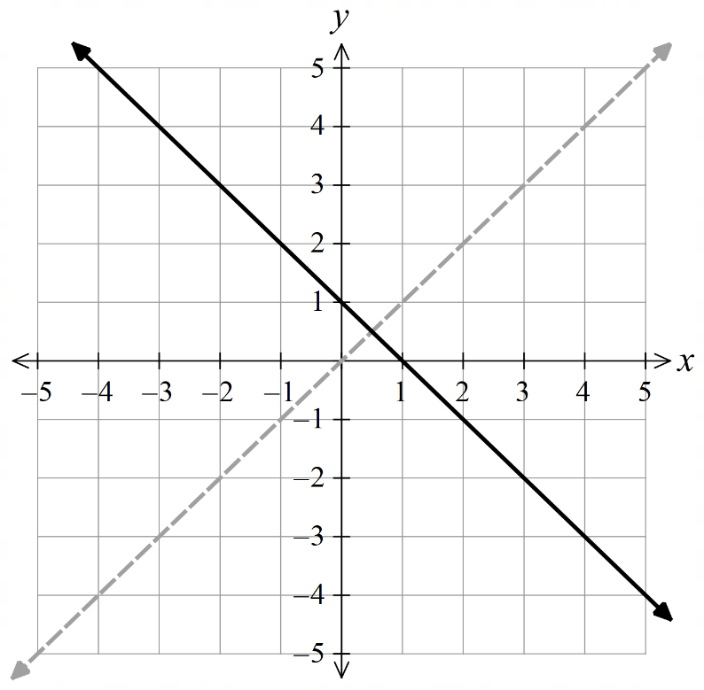 | 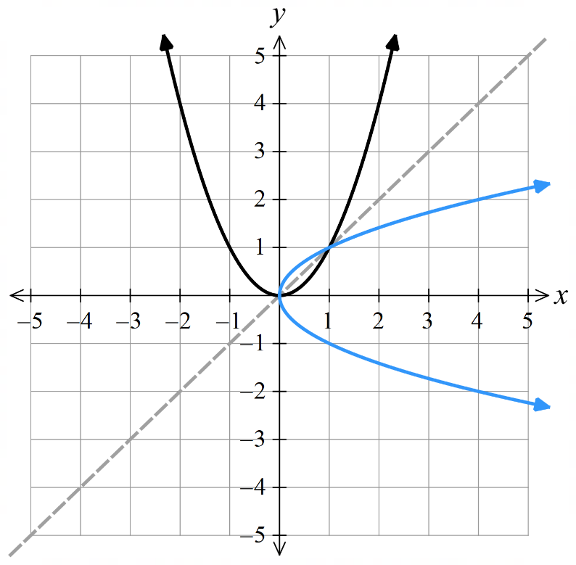
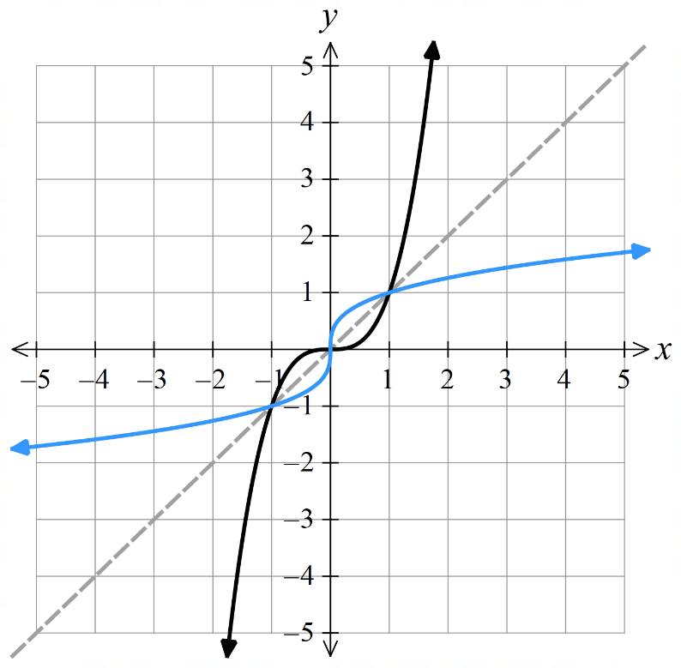 | 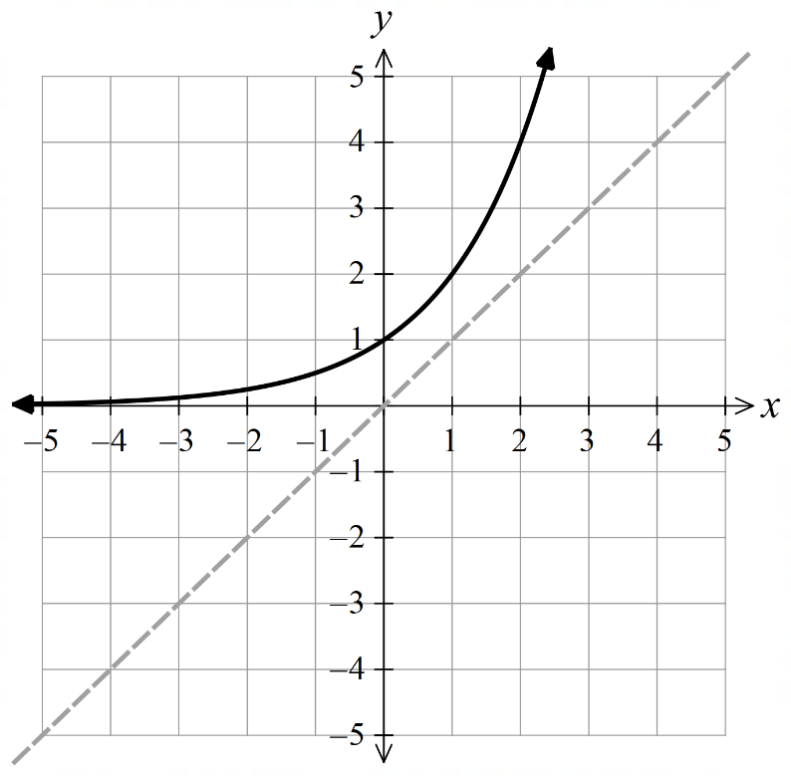  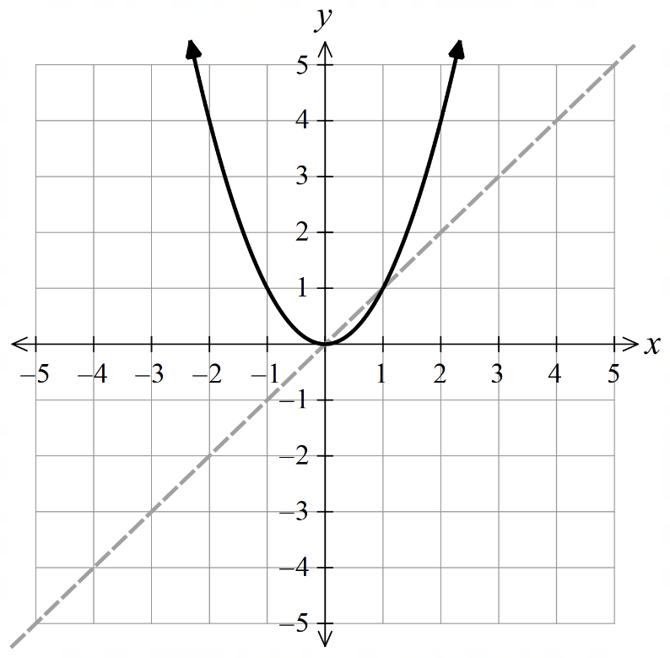  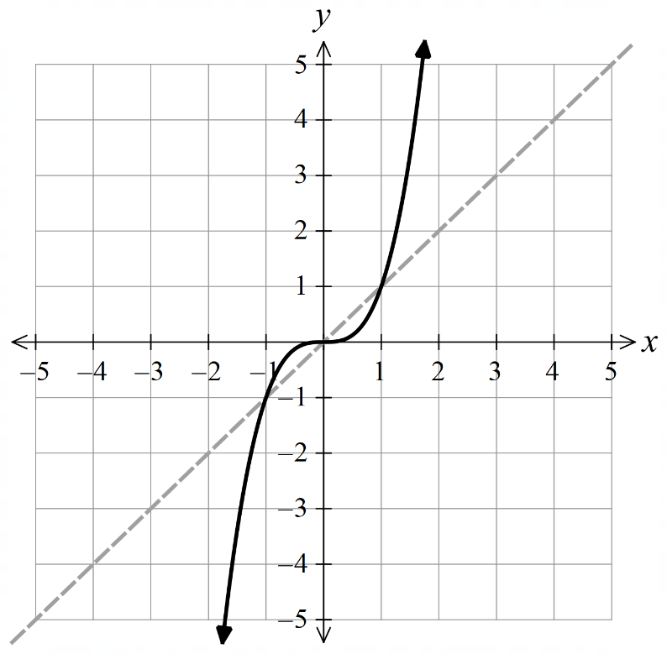  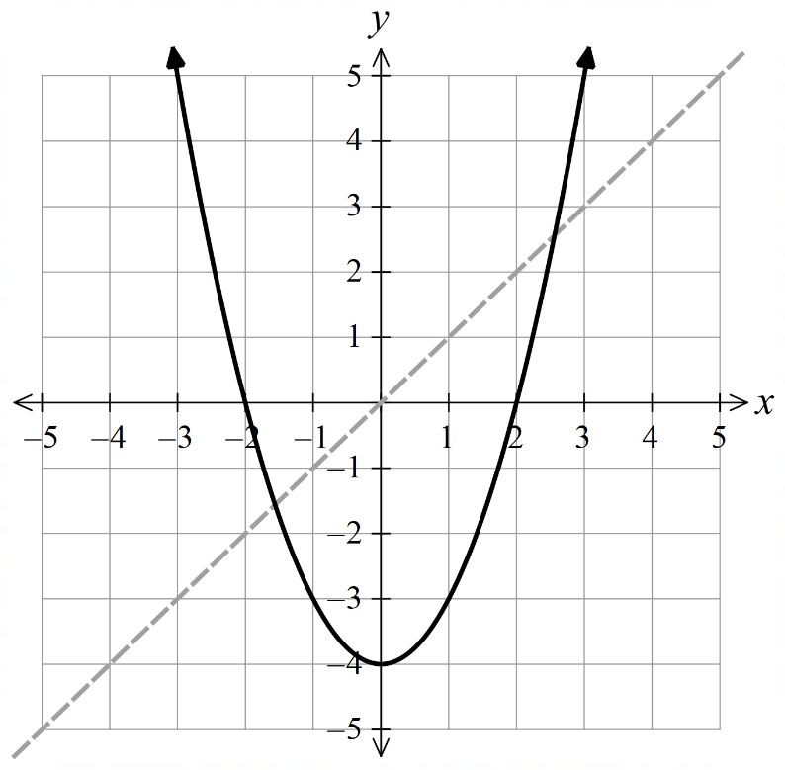  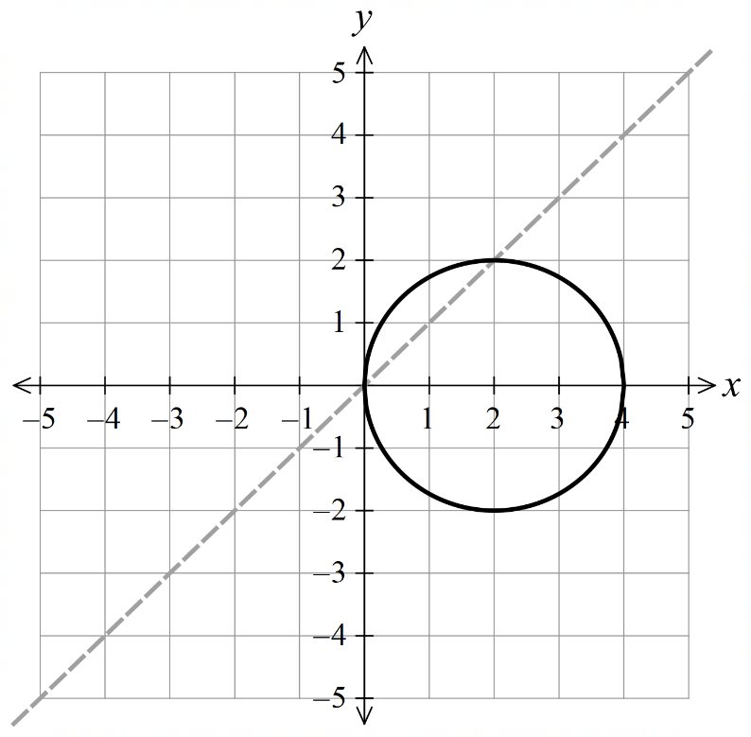  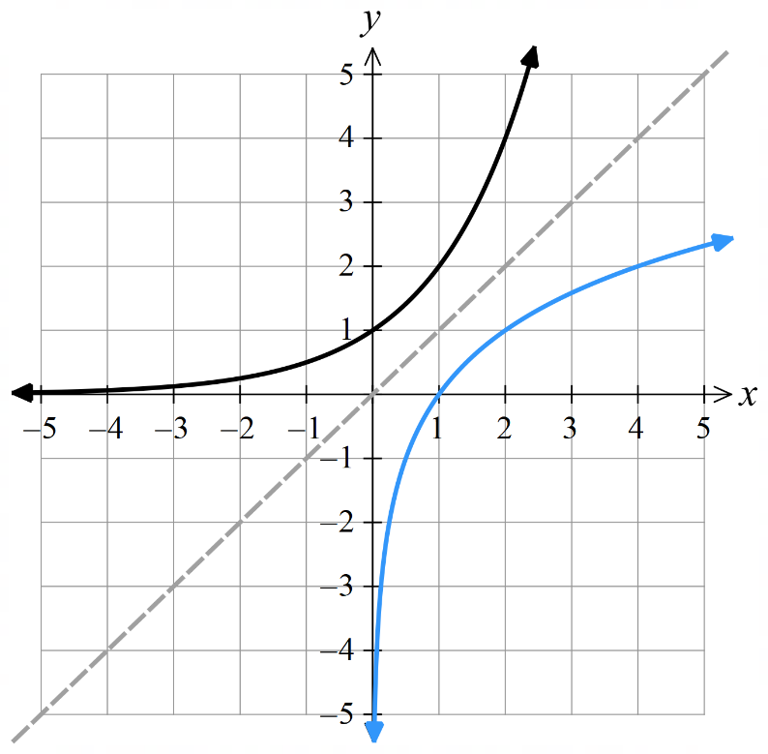
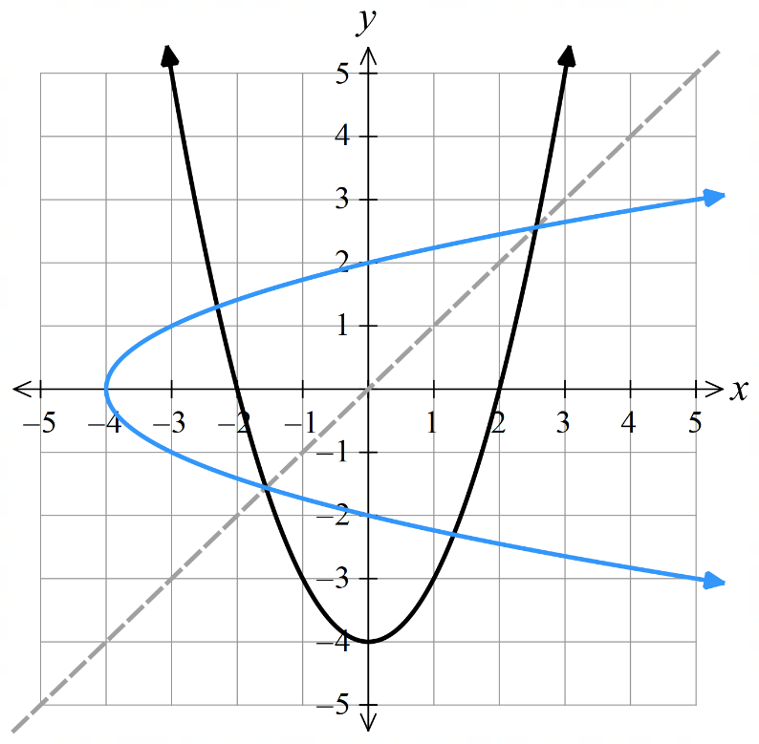 | 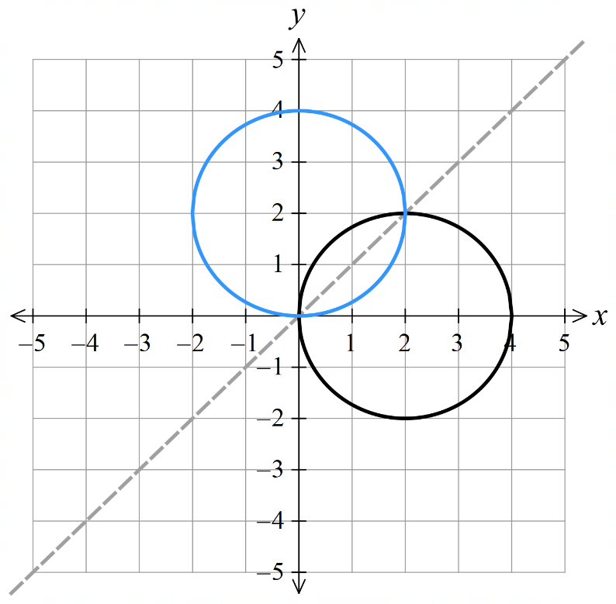

Inverse of a Relation

- Inverse Relations
Consider a function $f\left(x\right)$.
The inverse function, $f^{-1}\left(x\right)$ will undo the original function.
- $f^{-1}\left(x\right)$ is the inverse function and ${\left(f\left(x\right)\right)}^{-1}$ is the reciprocal function $\frac{1}{f\left(x\right)}$.

For a function that doubles all inputs $f\left(x\right)=2x$,
the inverse function is $f^{-1}\left(x\right)=$ $\frac{x}{2}$, which halves all inputs.
$\sin^{-1}\left(x\right)$ is the inverse of $\sin\left(x\right)$.

The composition of a function and its inverse is the original input.
$$f^{-1}\left(f\left(x\right)\right)=f\left(f^{-1}\left(x\right)\right)=x$$
Example:
Consider the linear function $f\left(x\right)=3x+5;$ the function multiplies the input by 3 and adds 5.
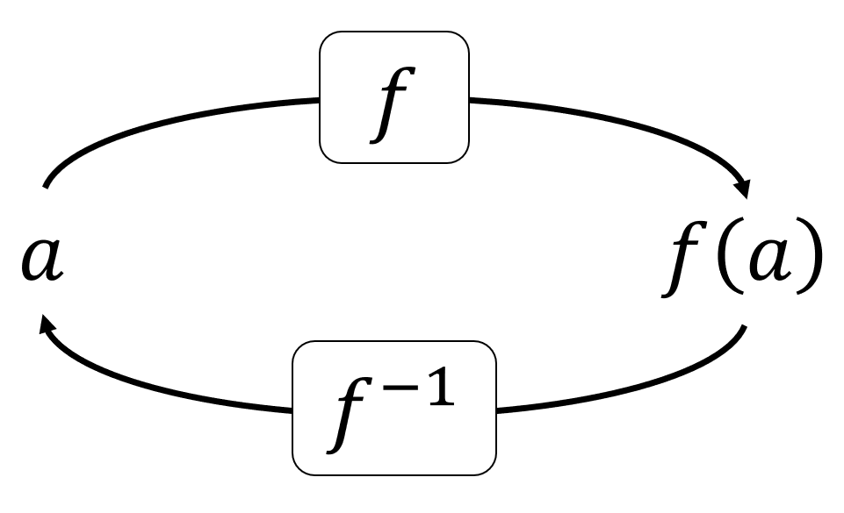

The inverse function would undo this by …………… 5 and …………… by 3.

So, we can write $f^{-1}\left(x\right)=$ $\frac{x-5}{3}$

Check that this works using the input $x=7$

$$f\left(7\right)=$$

Then put this into the inverse function.

$$f^{-1}\left(f\left(7\right)\right)=$$

- The Graph of a Relation and its Inverse
“multiply by 2, then add 3”  $$y=2x+3$$ | “subtract 3, divide by 2”  $$y=\frac{x-3}{2}$$
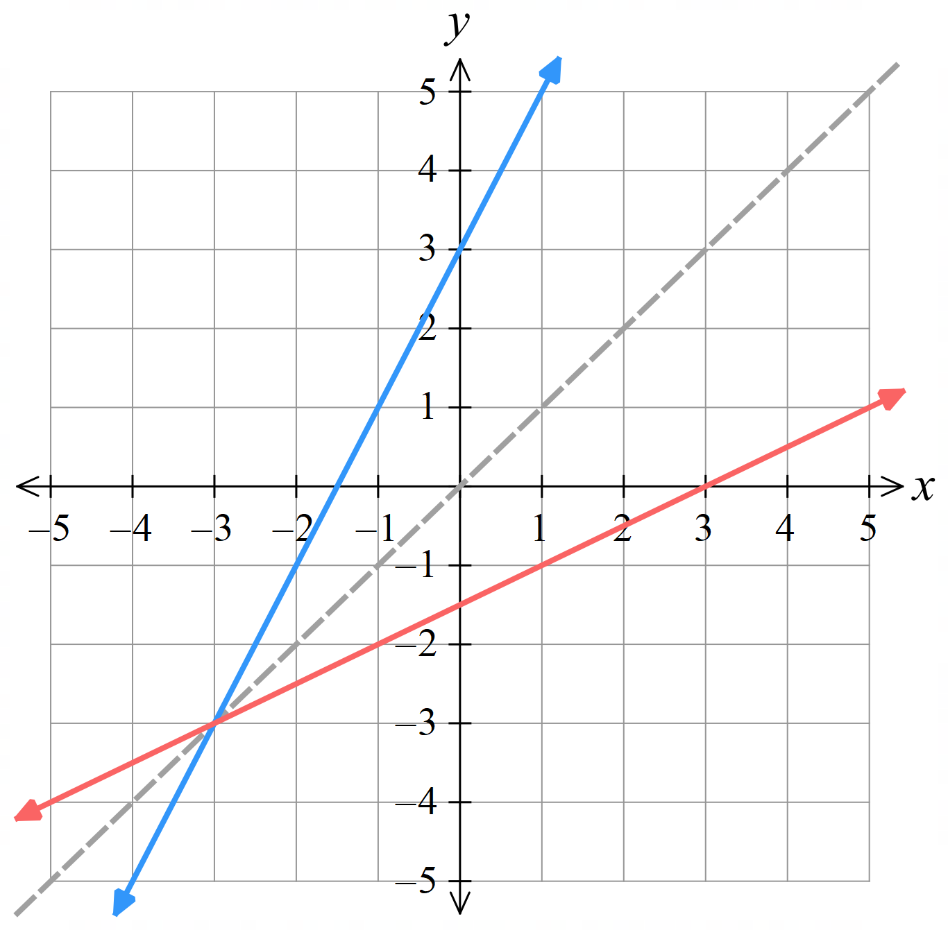

What do you notice about the two lines?

For the inverse relation, the coordinates of each pair are ………………
$$\left(x,y\right)$$
$$↓$$
$$\left(y,x\right)$$

This is the same as reflecting across the line ………………

This has the effect of swapping the domain and range.
- More examples: https://www.desmos.com/calculator/i6pos84gch

- Graph of the Inverse of a Relation
The graph of a relation and its inverse are reflections across the line $y=x$.
The domain of the original becomes the range of the inverse.
The range of the original becomes the domain of the inverse.

- Equation of the Inverse Relation
- The inverse of a function undoes what the original function does.
- The graph of a function and its inverse are reflections across $y=x$.
- Find a function’s inverse by swapping the $x$ and $y$ variables.
- The inverse of a function is not always a function. That’s why we call it an inverse relation.
We will explore this further in a future lesson

- Example Determine the inverse relation of a function
Worked Example | Your Turn
Determine the inverse relation of:  $$y=5x-2 \\ x=5y-2 \\ x+2=5y \\ y=\frac{x+2}{5}$$ | Determine the inverse relation of:  $$y=2x+1$$  $$y=\frac{x-1}{2}$$
Determine the inverse relation of:  $$y=5x^{3} \\ x=5y^{3} \\ \frac{x}{5}=y^{3} \\ y=\sqrt[3]{\frac{x}{5}}$$ | Determine the inverse relation of:  $$y=x^{3}-2$$  $$\sqrt[3]{x+2}$$
Determine the inverse relation of:  $$y=x^{2}+2x \\ x=y^{2}+2y \\ x+1=y^{2}+2y+1 \\ x+1={\left(y+1\right)}^{2} \\ y+1=±\sqrt{x+1} \\ y=-1±\sqrt{x+1}$$ | Determine the inverse relation of:  $$y=x^{2}+4x-7$$  $$y=-2±\sqrt{x+11}$$

Foundation
- Find the inverse relation.
- $y=3x$  $$y=\frac{x}{3}$$ | - $y=\sqrt[3]{x}$  $$y=x^{3}$$ | - $y=$ $\frac{x}{5}$  $$y=5x$$
- $y=x-5$  $$y=x+5$$ | - $y=x+3$  $$y=x-3$$ | - $y=$ $x^{3}$  $$y=\sqrt[3]{x}$$
- $y=3x-2$  $$y=\frac{x+2}{3}$$ | - $y=\frac{x}{2}+1$  $$y=2x-2$$ | - $y=3-$ $\frac{x}{2}$  $$y=6-2x$$
- $x-y+1=0$  $$y=x-1$$ | - $2x+5y-10=0$  $$y=-\frac{5x}{2}+5$$ | - $y=x^{3}+5$  $$y=\sqrt[3]{x-5}$$
- $y=\sqrt{x+2}$  $$y=x^{2}-2$$ | - $y=$ $\frac{3}{x+5}$  $$y=\frac{3}{x}-5$$ | - $y=$ $\frac{3}{x}$  $$y=\frac{3}{x}$$

- Find the inverse relation.
- $y=x^{2}$  $$y=±\sqrt{x}$$ | - $y=x^{2}+5$  $$y=±\sqrt{x-5}$$
- $y=2x^{4}$  $$y=± \sqrt[4]{\frac{x}{2}}$$ | - $y=x^{2}+8x$  $$y=±\sqrt{x+16}-4$$
- $y=4x-x^{2}$  $$y=±\sqrt{4-x}+2$$ | - $y=x^{2}+12x-11$  $$y=±\sqrt{x+47}-6$$

Development
- Swap $x$ and $y$ and solve for $y$ to find the inverse of each function.
$$y=\frac{1}{x}$$  $$y=\frac{1}{x}$$ | $$y=-x$$  $$y=-x$$ | $$y=\frac{2x-2}{x-2}$$  $$y=\frac{2x-2}{x-2}$$
What do you notice? What does this mean, graphically?

Each inverse is identical to the original function. The graph is symmetrical about the line $y=x$
- Consider ${\left(x-3\right)}^{2}+y^{2}=1$.
  - Graph this relation on the axes below.
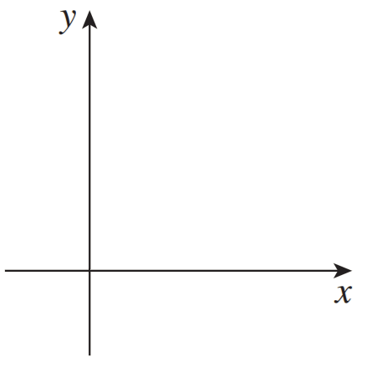
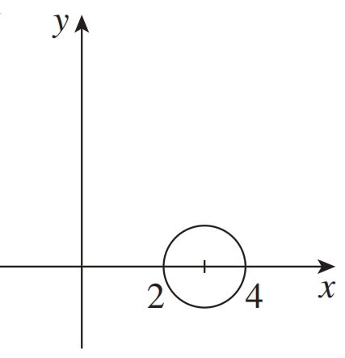
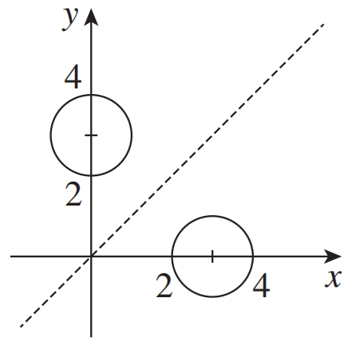

  - Determine the equation of the inverse relation (do not rearrange to make $y$ the subject)

$${\left(y-3\right)}^{2}+x^{2}=1$$
  - Sketch the relation on the same axes above.
  - Write down the domain and range of the original and of the inverse relation.
How are they related?
Original: domain: $2≤x≤4$, range: $-1≤y≤1$
Inverse: domain: $-1≤x≤1$, range: $2≤y≤4$
The domain and range of the inverse is swapped for a relation’s inverse.

  - State the domain and range of $y=$ $\frac{2}{x-1}$
D: $x∈R, x≠1$
R: $y∈R, y≠0$
  - Find the equation of the inverse.
$$y=\frac{2}{x}+1$$
  - State the domain and range of the inverse function.
D: $x∈R, x≠0$
R: $y∈R, y≠1$

- Sketch ${\left(x-3\right)}^{2}+y^{2}=9$  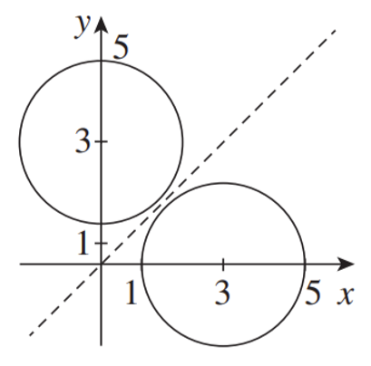  State the domain and range.  $$1≤x≤5$$  $$-3≤y≤3$$  On the same axis, graph the inverse.  State the domain and range of the inverse.  $$-3≤x≤3$$  $$1≤y≤5$$ | - Sketch $y=x^{2}+1$  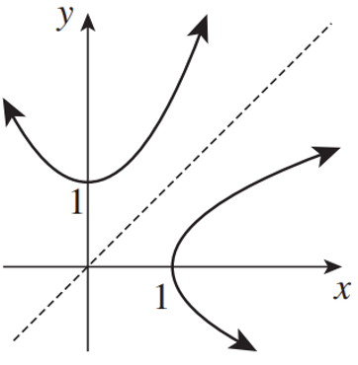  State the domain and range.  $$x∈R$$  $$y≥1$$  On the same axis, graph the inverse.  State the domain and range of the inverse.  $$x≥1$$  $$y∈R$$

- Determine each inverse algebraically by swapping $x$ and $y$ and then making $y$ the subject, then sketch the graph of each function and its inverse on the same axis.
- $y=3x-2$  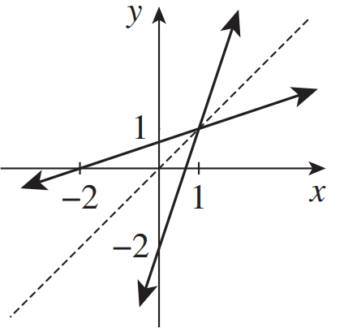  $$y=\frac{x+2}{3}$$ | - $y=x+1$  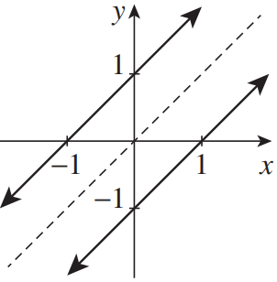  $$y=x-1$$
- $y=3-\frac{1}{2}x$  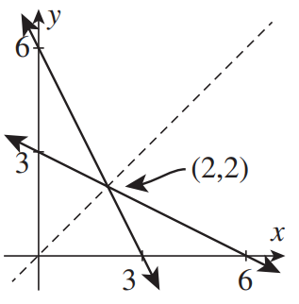  $$y=6-2x$$ | - $y=2$  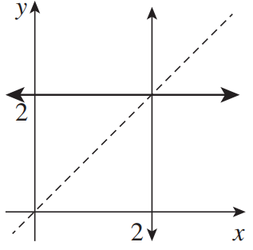  $$x=2$$

Mastery
- By first identifying the domain and range of these functions, identify the domain and range of the inverse.
- $y=3x+4$  D: all real $x$  R: all real $x$ | - $y=\sqrt{x}-3$  D: $x≥-3$  R: $y≥0$ | - $y=x^{2}+1$, for $x≥0$  D: $x≥1$  R: $y≥0$
- $y=$ $\frac{3}{x}$  D: all real $x$, $x≠0$  R: all real $y$, $y≠0$ | - $y=2^{x}$  D: $x>0$  R: all real $y$ | - $y=$ $\frac{1}{\sqrt{x+2}}$  D: $x>0$  R: $y>-2$

- When there are restrictions on a function, then the $x$ and $y$ must be swapped in these as well.
- Find the inverse of  $y=2x-3$, where $x>1$  $x=2y-3, y>1$  $$y=\frac{1}{2}\left(x+3\right), y>1$$ | - Find the inverse of  $y=3x-10,$where $x<2$  $$y=\frac{1}{6}\left(x+1\right), y<2$$
- Find the inverse of  $y=x^{3}+2$, where $x<3$  $$y=\sqrt[3]{x-2}, y<3$$ | - Find the inverse of  $y=13-6x,$where $x≥3$  $$y=\frac{1}{6}\left(13-x\right), y≥3$$

- For each part in the question above, your inverse should have a restriction in terms of $y$.
By solving the inequality, rewrite the restriction in terms of $x$.
The inverse was $y=\frac{1}{2}\left(x+3\right)$, $y>1$  $$∴\frac{1}{2}\left(x+3\right)>1$$  $$y=\frac{1}{2}\left(x+3\right),x>-1$$ | $$y=\frac{1}{6}\left(x+1\right), x<-4$$
$$y=\sqrt[3]{x-2},x<29$$ | $$y=\frac{1}{6}\left(13-x\right), x≤-5$$
- Consider the function $y=\sqrt{2x-1}$.
  - State the domain and range of this function.

Domain: $x≥$ $\frac{1}{2}$
Range: $y≥0$
  - Find the equation of the inverse and state the domain and range.
You must consider the restrictions on the original function, not just the equation of the inverse.
$$y=\frac{1}{2}\left(x^{2}+1\right)$$
Domain: $x≥0$
Range: $y≥$ $\frac{1}{2}$
  - Find the coordinates of the point where the original function intersects $y=x$.

$$\left(1,1\right)$$
  - Explain why this point also represents where the original function intersects with the inverse.

A function and its inverse has symmetry about $y=x$,
so any point on the line $y=x$ will stay the same.
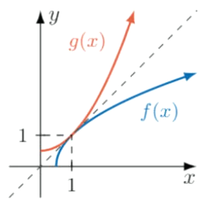
  - Hence, draw $y=\sqrt{2x-1}$ and its inverse on the same set of axes.

- 2020 HSC Extension 1 Band 4
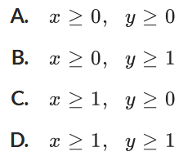
Given $f\left(x\right)=1+\sqrt{x}$, what are the domain and range of $f^{-1}\left(x\right)$?

Domain and range of $f\left(x\right)$ is $x≥0, y≥1$
This is swapped for the inverse, $∴C$

Determining if the Inverse Relation is a Function

- Equation of the Inverse Relation
- The inverse of a function is not always a function itself.
- Remember: if a relation passes the vertical line test, it is a function.
- Since the inverse swaps $x$ and $y$ coordinates,
if a function passes the horizontal line test, then its inverse will also be a function.
- Even functions do not have an inverse function, as its symmetry means it will fail the horizontal line test.

- Identify relations that will have an inverse function
Which of the following relations will have an inverse function?
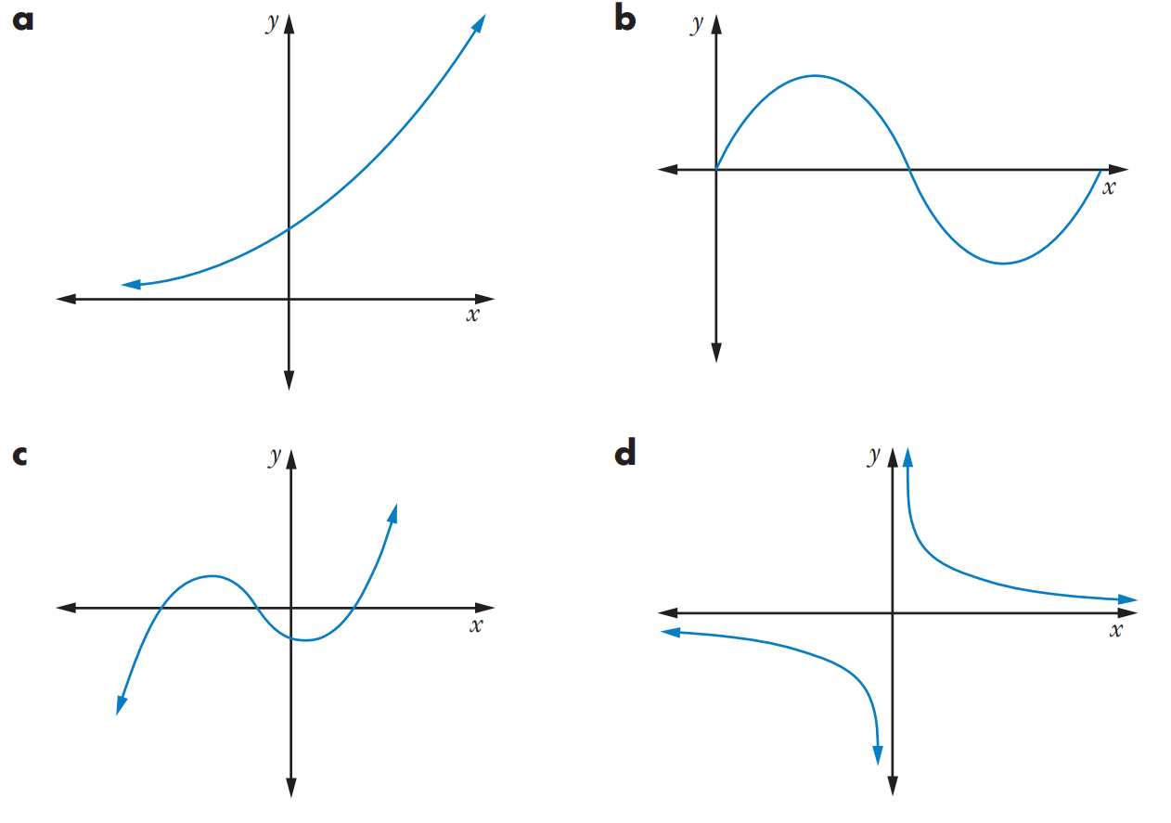

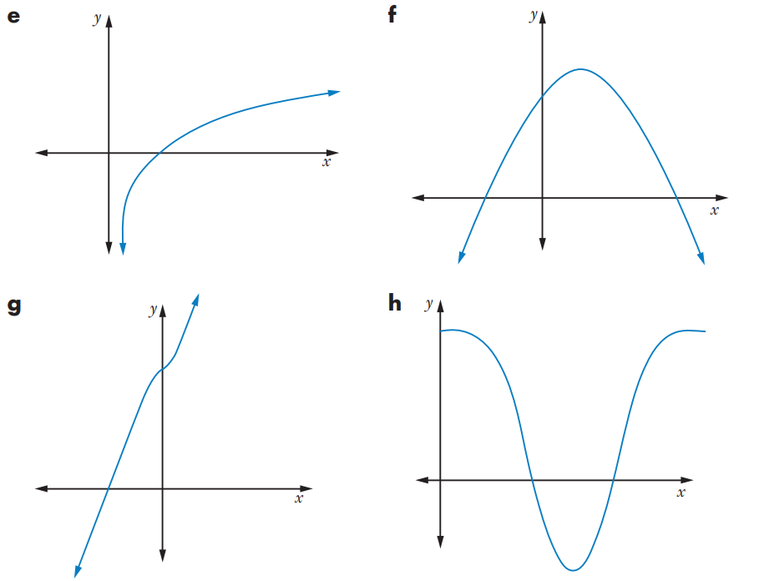
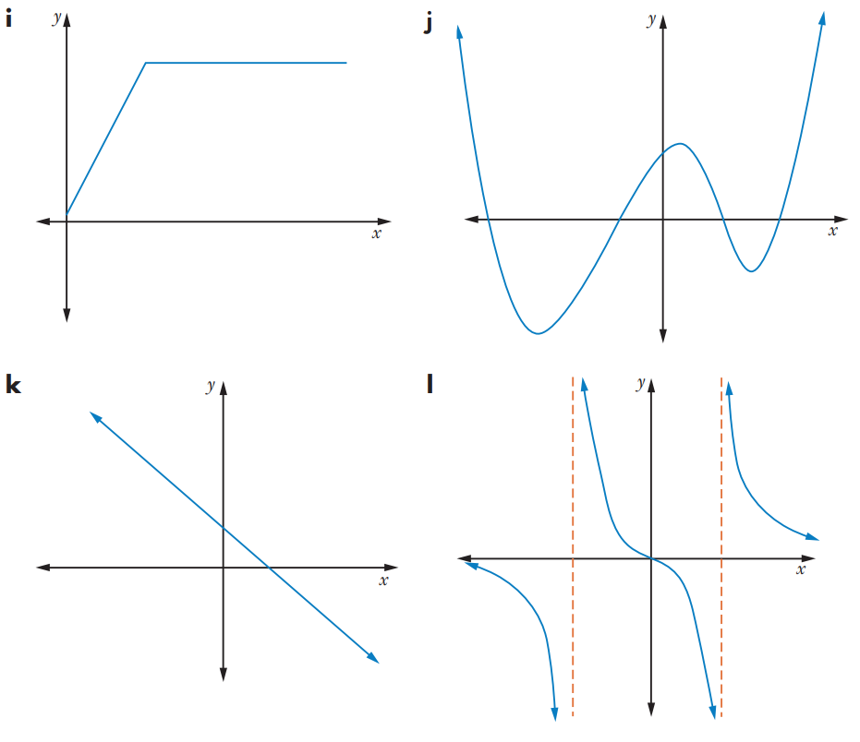

Foundation
- For each graph, decide whether the inverse will be a function.
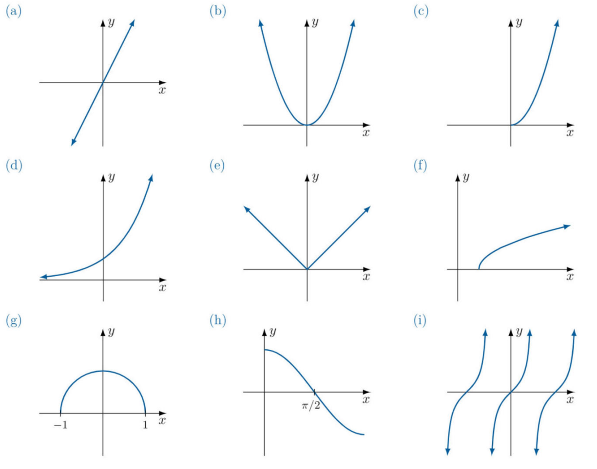  Inverse is a function | Inverse not a function | Inverse is a function
Inverse is a function | Inverse not a function | Inverse is a function
Inverse not a function | Inverse is a function | Inverse not a function

- Explain why these functions do not have inverse functions.
$$f\left(x\right)=x^{2}-5, f\left(x\right)=x^{4}, f\left(x\right)=3^{x^{2}}, y=\left|3x-2\right|$$

There are all even functions.

Development
- Classify whether these relations are one-to-one, and therefore whether it is a function that has an inverse functions.
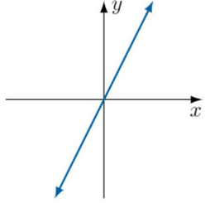  one-to-one | 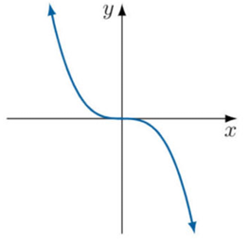  one-to-one | 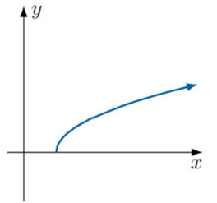  one-to-one
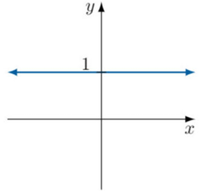  Not one-to-one | 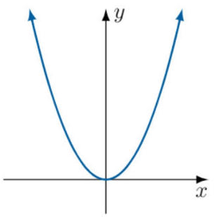  Not one-to-one | 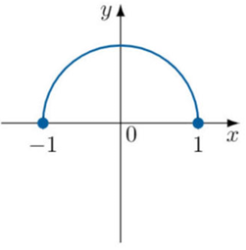  Not one-to-one
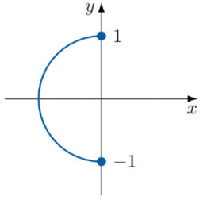  Not one-to-one | 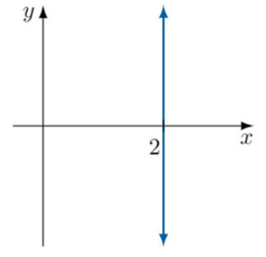  Not one-to-one | 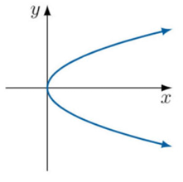  Not one-to-one
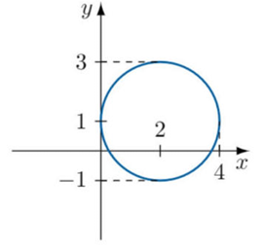  Not one-to-one | 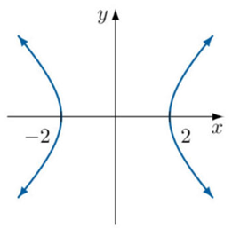  Not one-to-one | 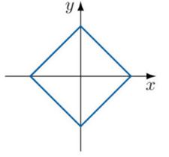  Not one-to-one

Mastery
- When will the inverse of a relation be a function?

One-to-one and one-to-many relations have an inverse that is a function.
- When will the inverse of a function be itself a function?

Only one-to-one functions have an inverse that is a function.
- Explain why the inverse of an even function will not be a function.

Even functions satisfy $f\left(-x\right)=f\left(x\right)$, they have at least 2 $x$-values for each $y$-value.
Therefore, the inverse will have at least 2 $y$-values for each $x$-value, so is not a function.
- Emmy says:

The inverse of an odd function will always be a function.
An example is $y=2x$.

Show that she is incorrect by giving a counterexample.

A counterexample is $y=x\left(x-1\right)\left(x+1\right)$. This is an odd function that fails the horizontal line test.
- Show that $f\left(x\right)=\frac{2^{x}+2^{-x}}{2}$ does not have an inverse function.

$$f\left(-x\right)=\frac{2^{-x}+2^{x}}{2}=f\left(x\right)$$
This is an even function, so its inverse is not a function.

Inverse Functions

- Finding the Inverse Function
The inverse function is the set of original ordered pairs, but with input and output swapped.
$$f=\left\{\left(a,A\right), \left(b,B\right), \left(c,C\right)\right\} \\ f^{-1}=\left\{\left(A,a\right), \left(B,b\right), \left(C,c\right)\right\}$$

If you are given $f\left(x\right)$ and asked to find $f^{-1}\left(x\right)$:
- Rewrite $f\left(x\right)=$as $y=$
- Swap the $x$ and $y$.
- Rearrange for $y$, then write as $f^{-1}\left(x\right)$.

- Example Find $f^{-1}\left(x\right)$ given $f\left(x\right)$, no domain restrictions
$f\left(x\right)=x^{3}+2,$ Find $f^{-1}\left(x\right)$.
1. $y=x^{3}+2$

2. $x=y^{3}+2$

3. $y^{3}=x-2$
$y=\sqrt[3]{x-2}$
$f^{-1}\left(x\right)=\sqrt[3]{x-2}$

- Guided Practice
Find the inverse function of each of these functions.
- $f\left(x\right)=3x-8$

$$f^{-1}\left(x\right)=\frac{x+8}{3}$$
- $f\left(x\right)=2x^{5}+7$

$$f^{-1}\left(x\right)=\sqrt[5]{\frac{x-7}{2}}$$
- $f\left(x\right)=$ $\frac{1}{x-2}$

$$f^{-1}\left(x\right)=\frac{1}{x}+2$$

- Solving Problems involving Inverses
Many problems can be solved by applying the function to both sides of the equation.
This helps us avoid finding the inverse function.

- Example Solve problems involving inverse functions
$h\left(x\right)=2^{5x}$. Find the value of $x$ when $h^{-1}\left(x\right)=3$
$$h^{-1}\left(x\right)=3 \\ h\left(h^{-1}\left(x\right)\right)=h\left(3\right) \\ x=h\left(3\right) \\ x=2^{15}$$

- Guided Practice
- $j\left(x\right)=3^{x}$. Find $x$ when $j^{-1}\left(x\right)=4$.

$$x=81$$
- $g\left(x\right)=$ $\frac{4x+1}{x-2}$. Find the value of $x$ when $g^{-1}\left(x\right)=5$.

$$x=7$$
- $f\left(x\right)=2x^{3}-7$. Find the value of $x$ when $f^{-1}\left(x\right)=-2$.

$$x=-23$$
- $h\left(x\right)=5^{x+1}$. Find $h^{-1}\left(125\right)$.
Hint: let $y=h^{-1}\left(125\right)$ and apply $h$ to both sides, then solve.

$$x=2$$

Foundation
- Find the inverse function of:
- $f\left(x\right)=2x+5$  $$f^{-1}\left(x\right)=\frac{x-5}{2}$$ | - $f\left(x\right)=4-3x$  $$f^{-1}\left(x\right)=\frac{4-x}{3}$$
- $f\left(x\right)=x^{3}-2$  $$f^{-1}\left(x\right)=\sqrt[3]{x+2 }$$ | - $f\left(x\right)=$ $\frac{1}{x-5}$  $$f^{-1}\left(x\right)=\frac{1}{x}+5$$
- $f\left(x\right)=$ $\frac{x+1}{6}$  $$f^{-1}\left(x\right)=6x-1$$ | - $f(x)=12-3x$  $$f^{-1}\left(x\right)=4-\frac{x}{3}$$
- $f(x)=$ $\frac{4}{x+2}$  $$f^{-1}\left(x\right)=\frac{4-2x}{x}$$ | - $f(x)=$ $\frac{5}{x+3}$  $$f^{-1}\left(x\right)=\frac{5}{x}-3$$

- Let $f\left(x\right)=2x-8$ and $g\left(x\right)=$ $\frac{1}{2}$ $x+4$.
  - Find:
- $g\left(f\left(5\right)\right)$  5 | - $f\left(g\left(5\right)\right)$  5

  - Find:
- $g\left(f\left(x\right)\right)$  $$x$$ | - $f\left(g\left(x\right)\right)$  $$x$$

  - What can you conclude about $f\left(x\right)$ and $g\left(x\right)$?
$g\left(x\right)$ is the inverse function of $f\left(x\right)$ (and vice versa)
- Given $g\left(x\right)=3x^{3}-1$
  - Find an expression for $g^{-1}\left(x\right)$

$$g^{-1}\left(x\right)=\sqrt[3]{\frac{x+1}{3}}$$
  - Solve the equation $g^{-1}\left(x\right)=2$

$$x=23$$
- Find the inverse of each of the functions $g(x)=6-x$ and $h(x)=\frac{3}{x}$
What do you notice?

$$g^{-1}\left(x\right)=6-x, h^{-1}\left(x\right)=\frac{3}{x}$$
The inverse function is the original function (involution)
- Let $f$ be the function that converts a temperature in Celsius, $x,$ to Fahrenheit.
$$f\left(x\right)=\frac{9}{5}x+32$$
Find the inverse function that converts Fahrenheit to Celsius.

$$f^{-1}\left(x\right)=\frac{5}{9}\left(x-32\right)$$
Where $x$ is temperature in Fahrenheit

- Given $h\left(x\right)=3x+19$ and $k\left(x\right)=2x-10$, work out the value of $x$ for which $h^{-1}\left(x\right)=k^{-1}\left(x\right)$

$$x=-68$$
- Find the inverse of $h\left(x\right)=$ $\frac{3x+4}{5x-6}$

$$h^{-1}\left(x\right)=\frac{6x+4}{5x-3}$$

Development
- For each function, find its inverse $f^{-1}\left(x\right)$ then verify $f\left(f^{-1}\left(x\right)\right)=x$ and $f^{-1}\left(f\left(x\right)\right)=x$.
- $f\left(x\right)=x^{3}+1$  $$f^{-1}\left(x\right)=\sqrt[3]{x-1}$$  Verify $f\left(f^{-1}\left(x\right)\right)=x$  Verify $f^{-1}\left(f\left(x\right)\right)=x$ | - $f\left(x\right)=$ $\frac{1-x}{3+x}$  $$f^{-1}\left(x\right)=\frac{1-3x}{1+x}$$  Verify $f\left(f^{-1}\left(x\right)\right)=x$  Verify $f^{-1}\left(f\left(x\right)\right)=x$ | - $f\left(x\right)=\sqrt[3]{x-7}$  $$f^{-1}\left(x\right)=x^{3}+7$$  Verify $f\left(f^{-1}\left(x\right)\right)=x$  Verify $f^{-1}\left(f\left(x\right)\right)=x$

- $f(x)=3x+4$ and $g(x)=ax^{2}$
  - Work out an expression for $f^{-1}(x)$
  - Given that $f\left(g\left(3\right)\right)=85$, find the value of $a$.

$$f^{-1}(x)=\frac{x-4}{3}$$
$$g\left(3\right)=9a$$
$$f\left(9a\right)=27a+4=85$$
$$a=3$$
- $f\left(x\right)=ax+8$ and $g\left(x\right)=2x-3$
  - Work out an expression for $f^{-1}(x)$
  - Given $fg(2)=13$, find the value of $a$.

$$f^{-1}\left(x\right)=\frac{x-8}{a} \\ g\left(2\right)=1$$
$$f\left(1\right)=a+8=13$$
$$a=5$$
- $f(x)=x^{2}-1$ and $g(x)=4x+5$
  - Work out an expression for $f^{-1}(x)$
  - Work out an expression for $g^{-1}(x)$
  - Given that $fg(x)=3gf(x)$, show that $4x^{2}+40x+21=0$
$$f^{-1}(x)=\sqrt{x+1}, g^{-1}(x)=\frac{x-5}{4}$$

$$fg\left(x\right)={\left(4x+5\right)}^{2}-1=16x^{2}+40x+24$$
$$gf\left(x\right)=4\left(x^{2}-1\right)+5=4x^{2}+1$$
$$16x^{2}+40x+24=3\left(4x^{2}+1\right) \\ 4x^{2}+40x+21=0$$
- $f(x)=2x+4$ and $g(x)=3x-8$
  - Find $f^{-1}(x)$ and $g^{-1}(x)$
  - Find an expression for $f\left(g\left(x\right)\right)$
  - Find an expression for the inverse of $f\left(g\left(x\right)\right)$
  - Is $(fg)^{-1}(x)$ the same as $f^{-1}\left(g^{-1}\left(x\right)\right)$?
  - Is $(fg)^{-1}(x)$ the same as $g^{-1}\left(f^{-1}\left(x\right)\right)$?

$$f^{-1}(x)=\frac{x-4}{2}, g^{-1}(x)=\frac{x+8}{3} \\ fg\left(x\right)=2\left(3x-8\right)+4=6x-12 \\ {\left(fg\right)}^{-1}(x)=\frac{x+12}{6} \\ f^{-1}g^{-1}(x)=\frac{x-4}{6} not the same as {\left(fg\right)}^{-1}(x) \\ g^{-1}f^{-1}(x)=\frac{x+12}{6} yes, the same as {\left(fg\right)}^{-1}(x)$$

Mastery

  - Let $f\left(x\right)$ be the function “increase $x$ by 50%”. Write the equation for $f\left(x\right)$.
$$f\left(x\right)=1.5x$$

  - A student in Year 8 says:
If you increase by 50%, then you can get back to the original by decreasing by 50%.

Let $g\left(x\right)$ be “decrease $x$ by 50%.”
    - Write the equation for $g\left(x\right)$.
$$g\left(x\right)=0.5x$$
    - Show that she is incorrect by finding $g\left(f\left(x\right)\right)$.

$$g\left(1.5x\right)=0.5\left(1.5x\right)=0.75x$$
Since $g\left(f\left(x\right)\right)≠x$, $g\left(x\right)$ is not the inverse of $f\left(x\right)$
Therefore, a decrease of 50% will not undo an increase of 50%
  - What is the inverse function $f^{-1}\left(x\right)$?

$$f^{-1}\left(x\right)=\frac{x}{1.5}=\frac{2x}{3}$$
  - Therefore, to undo a 50% increase, what percentage do you need to decrease by?

$f^{-1}\left(x\right)=$ $\frac{2}{3}$ $x$, we need to decrease $x$ by a third,
so $33.\dot{3}\%$decrease

  - Find the inverse function of $f\left(x\right)=$ $\frac{1-x}{1+x}$.

$$f^{-1}\left(x\right)=\frac{1-x}{1+x}$$
  - What does this tell you about $f\left(f\left(x\right)\right)$?

$f\left(x\right)$ and $f^{-1}\left(x\right)$ is the same. So, if $f\left(x\right)$ is applied twice, you get the original back.
  - What does this tell you about the graph of $f\left(x\right)$?

It is symmetrical about the line $y=x$

  - Show that $\frac{x^{2}+x}{x^{2}+4x+3}$ can be written as $\frac{x}{x+a}$ where $a$ is a positive integer.

$$\frac{x(x+1)}{(x+1)(x+3)}=\frac{x}{x+3}, a=3$$
  - Hence, given $f\left(x\right)=\frac{x^{2}+x}{x^{2}+4x+3}$, find an expression for $f^{-1}\left(x\right)$

$$f^{-1}\left(x\right)=\frac{3x}{1-x}$$

- $h(x)=$ $\frac{2x+1}{x-1}$. Find an expression for $h^{-1}(x)$

$$h^{-1}\left(x\right)=\frac{x+1}{x-2}$$

  - Find an expression for $f^{-1}\left(x\right)$ when $f\left(x\right)=\frac{3x+7}{2x-8}$

$$f^{-1}\left(x\right)=\frac{8x+7}{2x-3}$$
  - Find a general expression for $g^{-1}(x)$ when $g(x)=\frac{ax+b}{cx+d}$

$$g^{-1}\left(x\right)=\frac{dx-b}{a-cx}$$
- $f(x)=x+2$ and $g(x)=\frac{1}{x-1}$
  - Find $g^{-1}\left(x\right)$
  - Find $f\left(g\left(x\right)\right)$ and give your answer in its simplest form.
  - Find the inverse of $f\left(g\left(x\right)\right)$, i.e. $(fg)^{-1}(x)$

$$g^{-1}\left(x\right)=\frac{1}{x}+1 \\ fg(x)=\frac{1}{x-1}+2=\frac{2x-1}{x-1} \\ {\left(fg\right)}^{-1}(x)=\frac{x-1}{x-2}$$
- $f\left(x\right)=4x+2$ and $g\left(x\right)=px+q$.
If $g(4)=7$ and $f^{-1}(18)=g(3)$, work out the values of $p$ and $q$.

$$p=3, q=-5$$

Domain Restrictions

- Restricting the Domain
When a function’s inverse is not a function, we need to restrict the domain so that the new restricted function has an inverse.
- We call a function invertible if its inverse is also a function.
- A function is invertible when it is one-to-one.
- Make a function invertible by limiting its domain based on turning points.
- Restrict domains so that the curve is strictly increasing or strictly decreasing, i.e., the gradient does not change sign, and include the turning point.

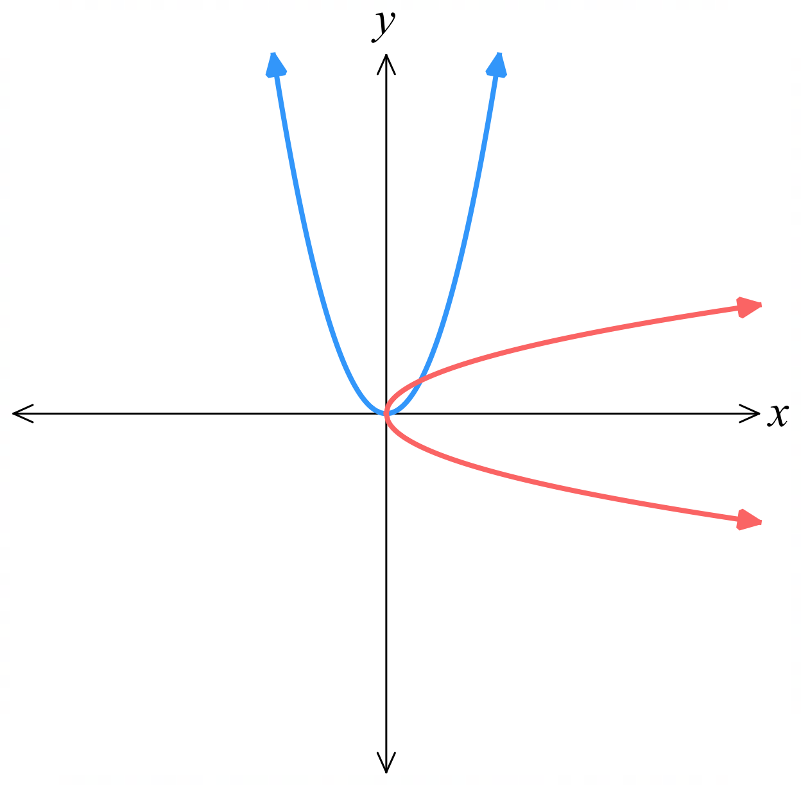  Consider $y=x^{2}$, inverse is $y^{2}=x$ (or $y=±\sqrt{x}$), which is not a function. | If we restrict $y=x^{2}$ to $x≥0$,  inverse is $y=\sqrt{x}, y≥0$,  which is a function. | If we restrict $y=x^{2}$ to $x≤0$,  inverse is $y=-\sqrt{x}, y≤0$,  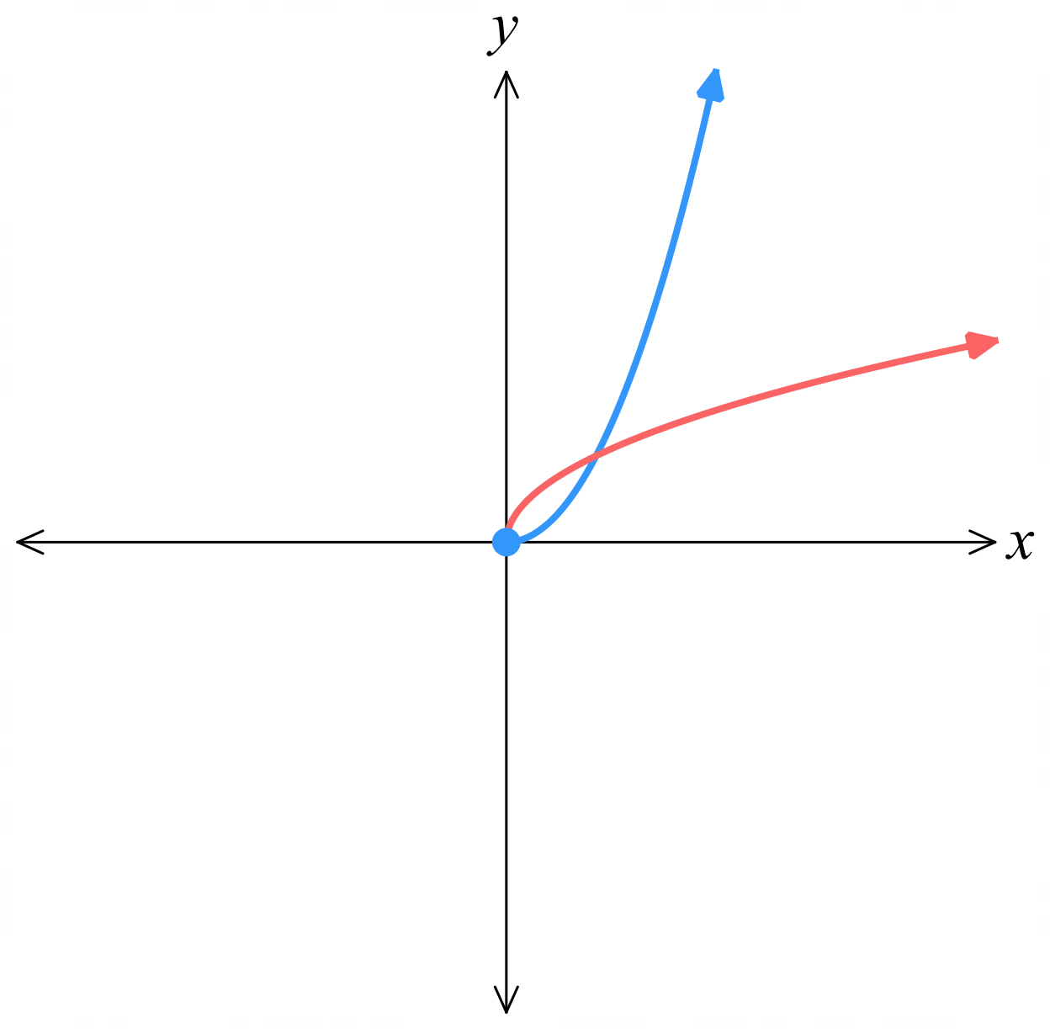  which is a function.  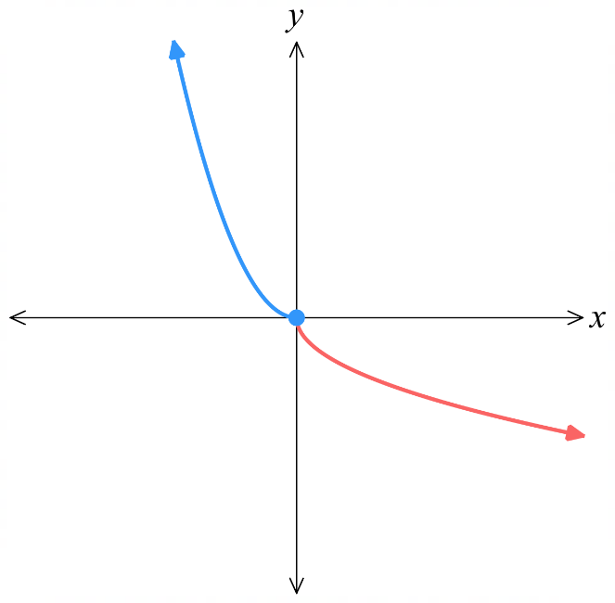

- Finding the Inverse Function (Domain Restrictions)
If the original function has a restriction, find the domain of the inverse by:
- Using the range of the original function as the domain of the inverse, or
- Sketching the reflection of the original function, or
- Solving the relevant inequality

- Example Find $f^{-1}\left(x\right)$ given $f\left(x\right)$and a domain restriction
$f\left(x\right)=6-2x$, $x>0$. Find $f^{-1}\left(x\right)$ and the new domain.
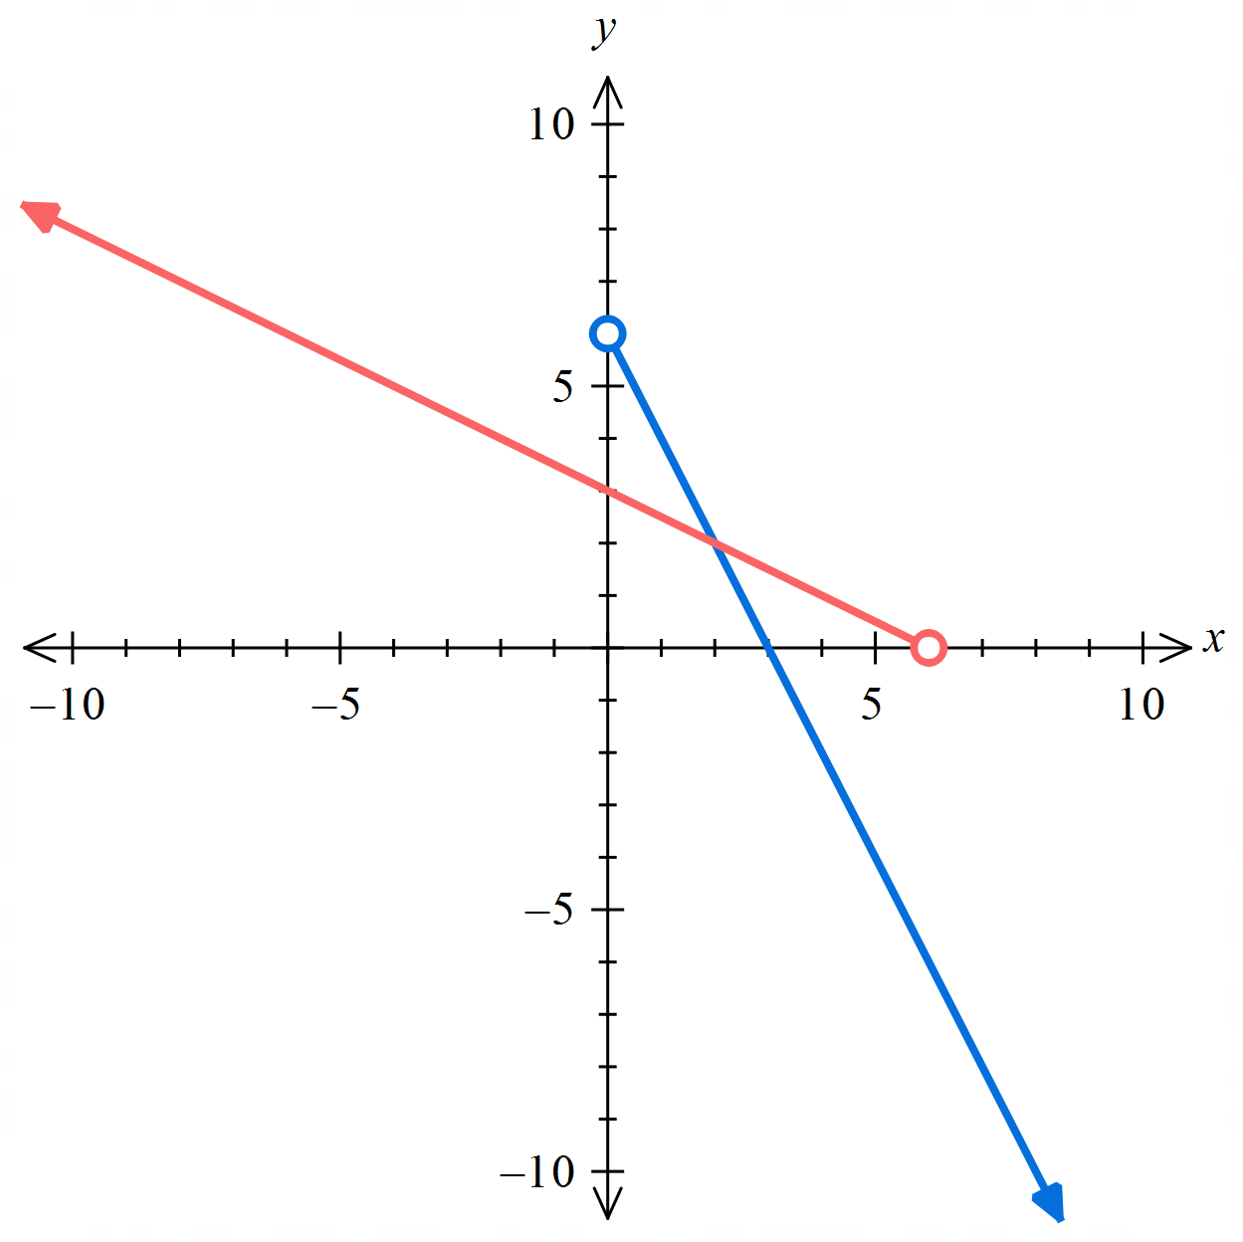
1. $y=6-2x, x>0$

2. $x=6-2y, y>0$

3. $-2y=x-6$ $y>0$
$y=-\frac{x}{2}+3$ $y>0$
$f^{-1}\left(x\right)=-\frac{x}{2}+3$ $y>0$

New domain: $-$ $\frac{x}{2}$ $+3>0$
$$-\frac{x}{2}>-3$$
$x<6$ (we can also consider the original range)

$∴f^{-1}\left(x\right)=-\frac{x}{2}+3$ $x<6$

- Guided Practice
Find the inverse function and any domain restrictions
- $f\left(x\right)=2x-5, x>3$

$$f^{-1}\left(x\right)=\frac{x+5}{2}, x>1$$
- $f\left(x\right)=\sqrt{x}+5$
Hint: to find the new domain, the easiest method is to consider the original range.

$$f^{-1}\left(x\right)={\left(x-5\right)}^{2}, x≥5$$

Foundation

  - The graph of $y=x\left(x+6\right)$ is shown. Find the coordinates of its turning point.
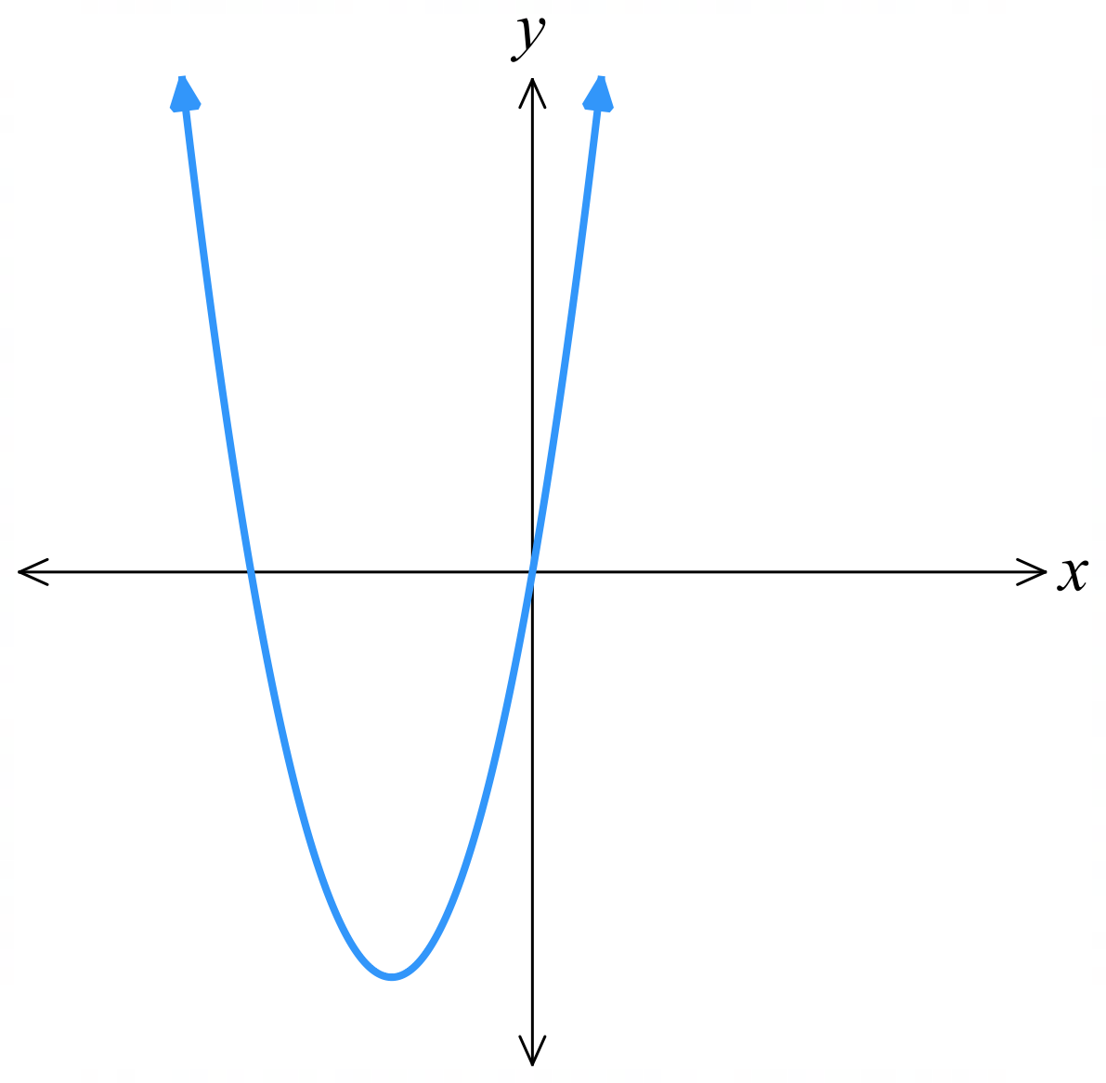

$$\left(-3, -9\right)$$
  - Find the domain over which the function $y=x\left(x+6\right)$ is one-to-one and increasing, including the turning point.

$$\left[-3,∞\right)$$
  - Find the inverse over this restricted domain, stating its domain and range.

$$y=\sqrt{x+9}-3$$
D: $\left[-9. ∞\right)$
R: $\left[-3, ∞\right)$
  - Find the domain over which the function $y=x\left(x+6\right)$ is one-to-one and decreasing, including the turning point.
$$\left(-∞, -3\right]$$
  - Find the inverse over this restricted domain, stating its domain and range.

$$y=-\sqrt{x+9}-3$$
D: $\left[-9. ∞\right)$
R: $\left(-∞,-3\right]$
- For each quadratic function, use the turning point to write down two ways to restrict the domain so that the inverse function exists.
- $y=1-x^{2}$  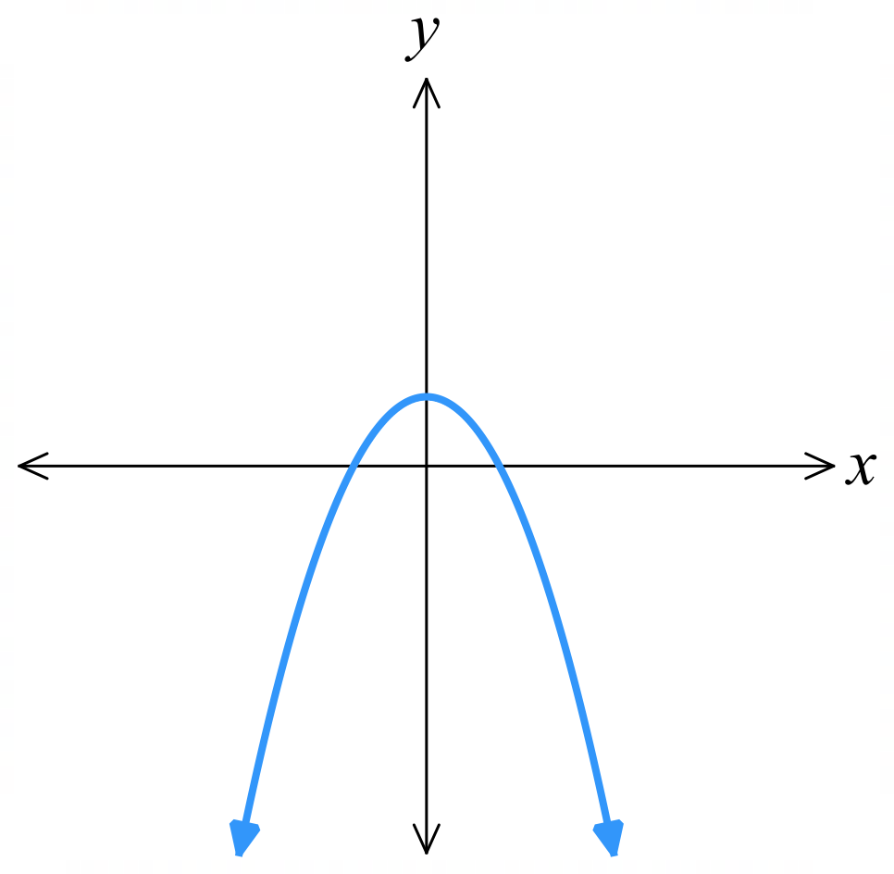  $x≥0$ and $x≤0$ | - $y={\left(x-2\right)}^{2}$  $x≥2$ and $x≤2$
- $y=\left(x-3\right)\left(x+1\right)$  $x≥1$ and $x≤1$ | - $y=x^{2}-6x+8$  $x≥3$ and $x≤3$
- 2019 VCE Methods Band 4
The function $f\left(x\right)=5x^{3}+10x^{2}+1$ is shown below.
In what domain will it have an inverse function?
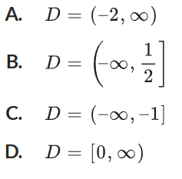
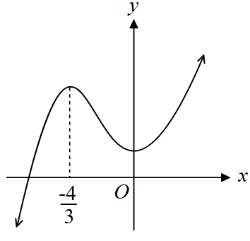

D

- $f\left(x\right)={\left(x-1\right)}^{2}-3$
  - Find the largest domain containing $x=3$ such that the inverse is defined.

$$x≥1$$
  - State the domain and range of $f^{-1}\left(x\right)$.

D: $x≥-3$
R: $y≥1$
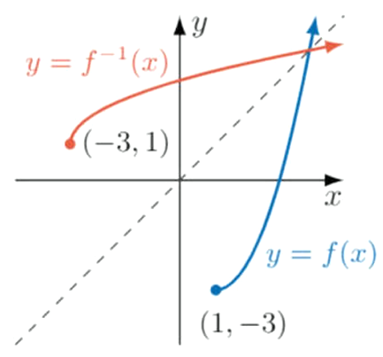
  - Sketch the graph of $y=f\left(x\right)$ with the restricted domain and $y=f^{-1}\left(x\right)$ on the same axes.

- Find the inverse function $f^{-1}\left(x\right)$, specifying the domain of the inverse. A sketch may help.
- $f\left(x\right)=9-x^{2}, x≥0$  $f^{-1}\left(x\right)=\sqrt{9-x}$, $x≥9$ | - $f\left(x\right)=x^{2}, x≤0$  $f^{-1}\left(x\right)=-\sqrt{x}$, $x≥0$ | - $f\left(x\right)=x^{2}-2x, x≥1$  $$f^{-1}\left(x\right)=1+\sqrt{1+x}, x≥1$$

Development
- Consider $f\left(x\right)=x^{2}-2x$
  - Find the largest domain containing $x=2$ such that the inverse is a function.

Turning point at $x=1$.
$$x≥1$$
  - State the range of $f\left(x\right)$ in that domain.

At $x=1, y=-1$
$$y≥-1$$
  - Show that the inverse relation is $y^{2}-2y-x=0$.

$$x=y^{2}-2x$$
$$y^{2}-2y-x=0$$
  - By quadratic formula or completing the square, show that making $y$ the subject yields
$$y=1±\sqrt{1+x}$$
$$y=\frac{2±\sqrt{4-4\left(1\right)\left(-x\right)}}{2}$$
$$y=\frac{2±\sqrt{4+4x}}{2}$$
$$y=\frac{2±2\sqrt{1+x}}{2}$$
$$y=1±\sqrt{1+x}$$

  - State the range of the inverse function.
$$y≥1$$
  - Hence, determine whether the inverse function is $y=1+\sqrt{1+x}$ or $y=1-\sqrt{1+x}$

$$y=1+\sqrt{1+x}$$
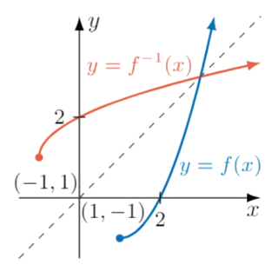
  - Hence sketch the graph of $y=f\left(x\right)$ and $y=f^{-1}\left(x\right)$ on the same axes.

- 2012 HSC Extension 1 Band 4
Let $f\left(x\right)=\sqrt{4x-3}$
  - Find the domain and range of $f\left(x\right)$.
$$4x-3≥0$$
$$x≥\frac{3}{4}$$
$$y≥0$$
  - Find an expression for $f^{-1}\left(x\right)$, stating the restriction.

$$f^{-1}\left(x\right)=\frac{1}{4}x^{2}+\frac{3}{4}, x≥0$$
  - Find the points where $y=f\left(x\right)$ and $y=x$ intersect.
$$x=\sqrt{4x-3}$$
$$x^{2}=4x-3$$
$$x^{2}-4x+3=0$$
$$\left(x-3\right)\left(x-1\right)=0$$
$$x=1, 3$$
$$∴\left(1,1\right), \left(3,3\right)$$
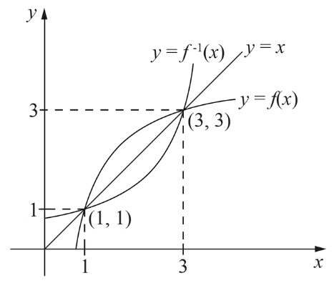
  - Therefore, on the same set of axes, sketch $y=f\left(x\right)$ and $y=f^{-1}\left(x\right)$.

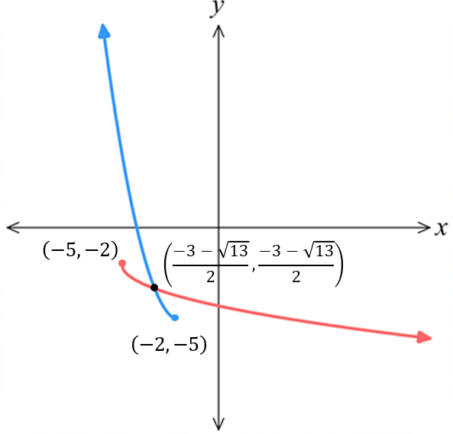
- Let $f\left(x\right)={\left(x+2\right)}^{2}-5$. Restrict $f\left(x\right)$ to the domain in which it is strictly decreasing and sketch the restricted function and its inverse $f^{-1}\left(x\right)$ on the same axis, clearly showing the point(s) of intersection.

$$f\left(x\right)={\left(x+2\right)}^{2}-5, x≤-2$$
$$f^{-1}\left(x\right)=-\sqrt{x+5}-2$$
Point of intersection:
Let $f\left(x\right)=x$
$${\left(x+2\right)}^{2}-5=x$$
$$∴x^{2}+3x-1=0$$
Using quadratic formula, $x=\frac{-3±\sqrt{13}}{2}$
Since $x≤-2,$ point of intersection at $\left(\frac{-3-\sqrt{13}}{2},\frac{-3-\sqrt{13}}{2}\right)$

Mastery
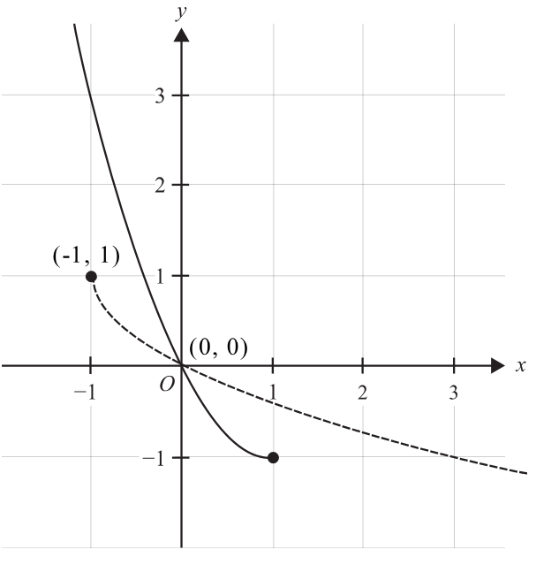
- 2023 VCE Methods Band 5
$f\left(x\right)=x^{2}-2x$ is given below, with domain restriction $x∈\left(-∞,1\right]$.
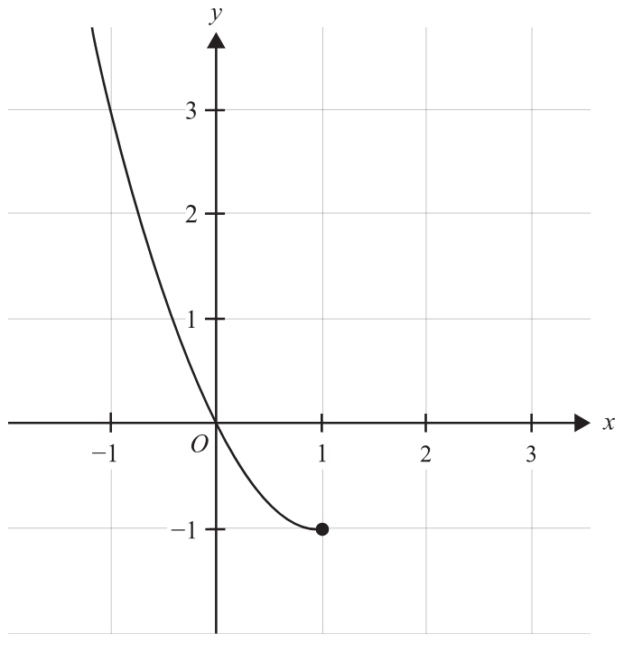

  - State the range of $f$.
$$\left[-1,∞\right)$$
  - Sketch the graph of the inverse function on the axes above.
Label any endpoints and intercepts.
  - Determine the equation of the inverse function $f^{-1}\left(x\right)$ and its domain.
$$x=y^{2}-2y$$
Complete the square $x={\left(y-1\right)}^{2}-1$
$$x+1={\left(y-1\right)}^{2}$$
$$y-1=±\sqrt{x+1}$$
By inspecting the sketch, consider the negative only
$$f^{-1}\left(x\right)=1-\sqrt{x+1}$$
D: $\left[-1,∞\right)$
- The diagram shows $f\left(x\right)=\sin{x}$ in the domain $x∈\left[-π, π\right]$.
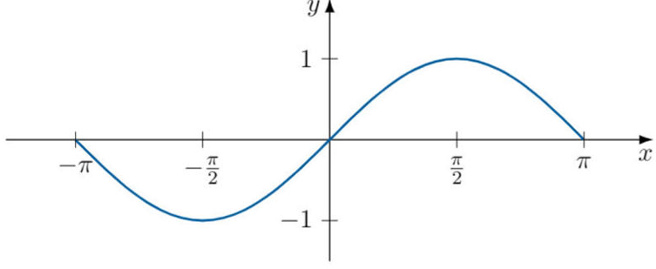

  - Find the largest possible domain such the inverse function exists.
$$-\frac{π}{2}≤x≤\frac{π}{2}$$
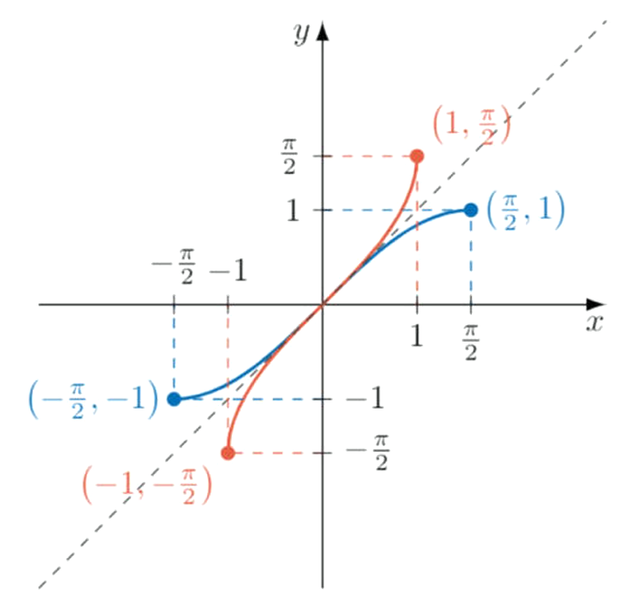
  - Sketch $y=f\left(x\right)$ with the restricted domain and $f^{-1}\left(x\right)$ on the same axis.

- 2004 HSC Extension 1 Band 5
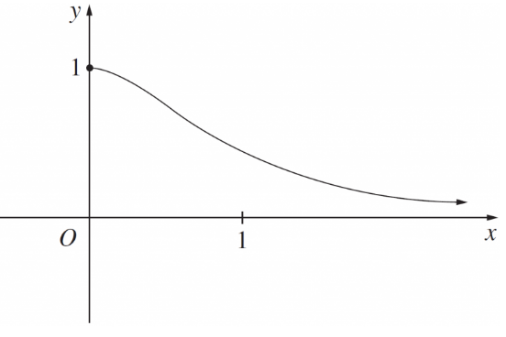
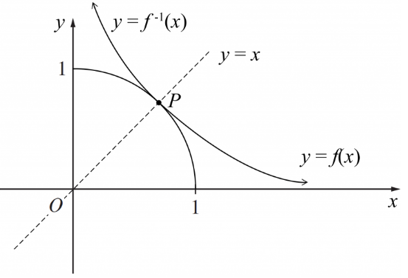
The diagram below shows $y=f\left(x\right)=$ $\frac{1}{1+x^{2}}$ for $x≥0$.

  - On the same set of axes, sketch $y=f^{-1}\left(x\right)$.
  - State the domain of $y=f^{-1}\left(x\right)$.
$$\left(0,1\right]$$
  - Find an expression for $y=f^{-1}\left(x\right)$.

$$y=\sqrt{\frac{1-x}{x}}, as y≥0$$
  - $y=f\left(x\right)$ and $y=f^{-1}\left(x\right)$ meet at a point $P$, let $α$ be the $x$-coordinate of $P$.
Show that $α$ is a root of the equation $x^{3}+x-1=0$
P occurs where $y=f\left(x\right)$ intersects with $y=x$
$$\frac{1}{1+x^{2}}=x$$
$$1=x\left(1+x^{2}\right)$$
$$1=x+x^{3}$$
$$x^{3}+x-1=0$$
$∴$ The root of $x^{3}+x-1=0$ will be the $x$-coordinate of $P$.

- Let $f\left(x\right)=x+$ $\frac{1}{x}$
  - Show that $f\left(\frac{1}{a}\right)=f\left(a\right)$.
$$f\left(\frac{1}{a}\right)=\frac{1}{a}+\frac{1}{\left(\frac{1}{a}\right)}$$
$$=\frac{1}{a}+a$$
$$=f\left(a\right)$$
  - Hence explain why $f\left(x\right)$ does not have an inverse function.

Since $f\left(a\right)$ and $f\left(\frac{1}{a}\right)$ are equal, there are two $x$ values that produce the same $y$-value.
This means the function is not one-to-one, so there won’t be an inverse function.

- 2018 HSC Extension 1 Band 5
The diagram shows $y=$ $\frac{x}{x^{2}+1}$
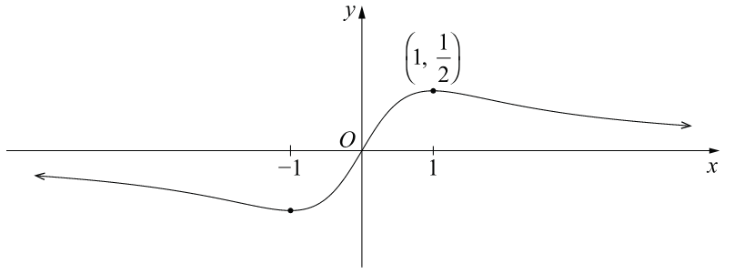
NOT TO SCALE

Consider $f\left(x\right)=$ $\frac{x}{x^{2}+1}$ for $x≥1$
  - State the domain and range of $f^{-1}\left(x\right)$.
Domain and range of $f\left(x\right):$ D: $x≥1$ R: $y≤$ $\frac{1}{2}$
$∴$ Domain and range of $f^{-1}\left(x\right):$ D: $x≤$ $\frac{1}{2}$ R: $y≥1$
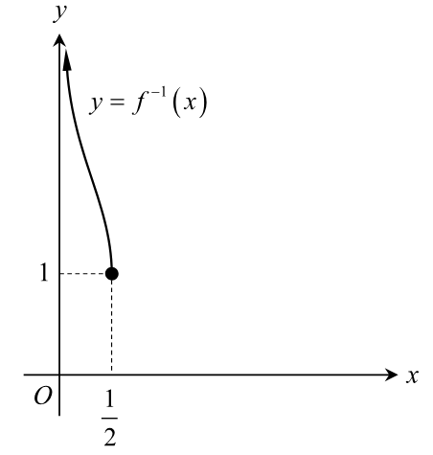
  - Sketch $y=f^{-1}\left(x\right)$ on a separate axis below.

  - Find an expression for $f^{-1}\left(x\right)$.
$$x=\frac{y}{y^{2}+1}$$
$$xy^{2}+x=y$$
$$xy^{2}-y+x=0$$
$$y=\frac{1±\sqrt{1-4x^{2}}}{2x}$$
Since $y≥1$
$$f^{-1}\left(x\right)=\frac{1+\sqrt{1-4x^{2}}}{2x}$$
  - Prove algebraically that $f\left(x\right)$ and $f^{-1}\left(x\right)$ do not intersect.
Let $f\left(x\right)=x$
$$\frac{x}{x^{2}+1}=x$$
$$x=x^{3}+x$$
$$x^{3}=0$$
$$x=0$$
The two graphs will intersect at $x=0$, however, $f\left(x\right)$ has a restriction $x≥1$, so there are no points of intersection.
- Decide whether the inverse of $y=\frac{2^{x}-2^{-x}}{2}$ is a function.
(You will need to differentiate it to decide whether it is strictly increasing or decreasing).

$f^{'}\left(x\right)=$ $\frac{\ln{2}\left(2^{x}+2^{-x}\right)}{2}$
$f^{'}\left(x\right)$ is always positive so it is strictly increasing in its entire domain.
This means the inverse will be a function.

- 2023 HSC Extension 1 Band 5
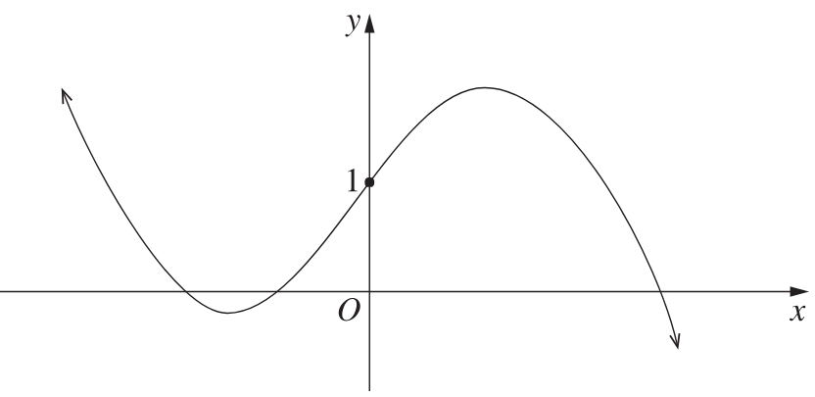
The graph of a cubic function $y=f\left(x\right)$ is shown below.

Which of these functions has an inverse relation whose graph has more than 3 points with an
$x$-coordinate of 1?
A. $y=\frac{1}{f\left(x\right)}$
B. $y=f\left(\left|x\right|\right)$
C. $y=\left|f\left(x\right)\right|$

Draw a quick sketch of each graph.
The one with more than 3 points of intersection with the line $y=1$ will have an inverse with more than 3 points with $x$-coordinate 1. $∴D$

Draw a quick sketch of each graph.
The one with more than 3 points of intersection with the line $y=1$ will have an inverse with more than 3 points with $x$-coordinate 1.
$$∴D$$

